**3-TIER WEB APPLICATION DEPLOYMENT IN CLOUD**

**3-Tier Architecture:**

The 3-tier architecture is a software architecture pattern that is commonly used for building web applications. It is based on the separation of concerns principle, which means that different components of the application are separated into distinct layers, each with its own responsibilities.

Here are the three tiers of the architecture:

**Presentation tier**:

This is the topmost layer of the application, also known as the user interface layer. Its main responsibility is to interact with the user and display information in a user-friendly manner. This layer typically consists of a web server that handles HTTP requests and generates dynamic HTML pages.

**Application tier**:

This is the middle layer of the application, also known as the business logic layer. Its main responsibility is to handle business logic and application functionality. This layer typically consists of a web application server that handles application logic and communicates with the database layer.

**Data tier**:

This is the bottommost layer of the application, also known as the data storage layer. Its main responsibility is to store and retrieve data from the database. This layer typically consists of a database server that stores and retrieves data and provides a mechanism for managing data access.

The three tiers are interconnected and communicate with each other to provide a complete application. The presentation tier interacts with the application tier to retrieve data and display it to the user, while the application tier interacts with the data tier to retrieve and store data.

By separating the application into distinct tiers, the 3-tier architecture provides several benefits, such as scalability, maintainability, and flexibility. It also allows for easier modification and testing of individual components, without affecting the entire application.

**Why do we use 3-tier architecture?**

We use the three-tier architecture for several reasons, including:

**Scalability:**

By separating the application into three distinct layers, we can scale each layer independently based on its needs. For example, we can add more web servers to the presentation layer, more application servers to the application layer, or more database servers to the data storage layer to handle increased traffic or data.

**Maintainability:**

Separating the application into three distinct layers also makes it easier to maintain and upgrade the system. Each layer can be upgraded or replaced separately without affecting the other layers. This makes it easier to make changes to the system without causing disruptions or downtime.

**Flexibility:**

The three-tier architecture allows us to use different technologies in each layer. For example, we can use a different programming language or framework in the presentation layer than in the application layer. This gives us more flexibility in designing and implementing the system.

**Security:**

The three-tier architecture also enhances the security of the system. The presentation layer only has access to the application layer, and the application layer only has access to the data storage layer. This reduces the risk of security breaches and makes it easier to implement security measures in each layer.

Overall, the three-tier architecture provides several benefits that make it a popular choice for building complex software systems. It offers scalability, maintainability, flexibility, and security, making it an ideal architecture pattern for many applications.

**Benefits of 3-tier architecture over traditional approach:**

The main difference between a three-tier architecture and a typical architecture for deploying a web application is the separation of concerns into three distinct layers.

In a typical architecture for deploying a web application, all of the components are typically located on a single server. This can make the application less scalable and harder to maintain, as changes to one component can affect the others.

In contrast, in a three-tier architecture, the application is divided into three distinct layers: presentation, application, and data storage. Each layer is deployed separately, often on different servers or virtual machines. This allows for better scalability, as each layer can be scaled independently to meet demand. It also makes the application easier to maintain, as changes to one layer do not affect the others.

For example, in a typical architecture, a web server might host the web application, the application logic, and the database. This can make it difficult to scale the application, as all of the components are tightly coupled. In a three-tier architecture, the web server might host only the presentation layer, with the application and data storage layers hosted on separate servers or virtual machines. This allows for better scalability and flexibility.

Overall, the three-tier architecture provides a more modular and flexible approach to deploying web applications, making it easier to scale, maintain, and update the application.

**Tools and Technologies used:**

* **Tools:**

A three-tier web application typically consists of three layers: presentation layer, application layer, and database layer. The main tools used in each layer of a three-tier web application may vary depending on the specific technology stack and programming language used, but here are some common examples:

**Presentation layer:**

HTML, CSS, and JavaScript for building the user interface

Client-side frameworks like React, Angular, or Vue.js for building dynamic web applications

Web browsers such as Chrome, Firefox, Safari, or Internet Explorer

Web servers such as Apache, Nginx, or IIS for serving web content to clients

**Application layer:**

Server-side programming languages like Java, Python, Ruby, or PHP for processing user requests and generating responses

Web application frameworks like Spring, Django, Ruby on Rails, or Laravel for building web applications faster and more efficiently

Web servers like Tomcat, Jetty, or Glassfish for running web applications

Application servers like JBoss, WebLogic, or WebSphere for providing additional features such as clustering, load balancing, and failover

**Database layer:**

Relational database management systems (RDBMS) like MySQL, PostgreSQL, or Oracle for storing and retrieving data

NoSQL databases like MongoDB, Cassandra, or Couchbase for storing and retrieving unstructured data

Object-relational mapping (ORM) frameworks like Hibernate, SQLAlchemy, or ActiveRecord for mapping between database tables and application objects

Data access layers like Java Persistence API (JPA), Django ORM, or Ruby on Rails Active Record for abstracting the database access from the application code.

These are just some of the many tools that can be used in each layer of a three-tier web application. The specific tools used will depend on the requirements of the application, the skills of the development team, and the available resources.

* **Technologies:**

The technologies used in a 3-tier web application deployment in the cloud.

Front-end technologies: The front-end of a web application is what users see and interact with in their browsers. Common front-end technologies include HTML, CSS, and JavaScript, as well as various libraries and frameworks such as React, Angular, or Vue.js.

Back-end technologies: The back-end of a web application handles the processing of data and business logic. Common back-end technologies include programming languages such as Java, Python, or PHP, as well as frameworks like Spring, Flask, or Laravel.

Database technologies: The database is where an application stores its data. Common database technologies include relational databases such as MySQL or PostgreSQL, as well as NoSQL databases such as MongoDB or Cassandra.

Cloud infrastructure technologies: In order to deploy a 3-tier web application in the cloud, you would need to use various cloud infrastructure technologies, such as virtual machines, load balancers, and storage services. These technologies are typically provided by cloud providers like AWS, Azure, or GCP.

**Architecture:**

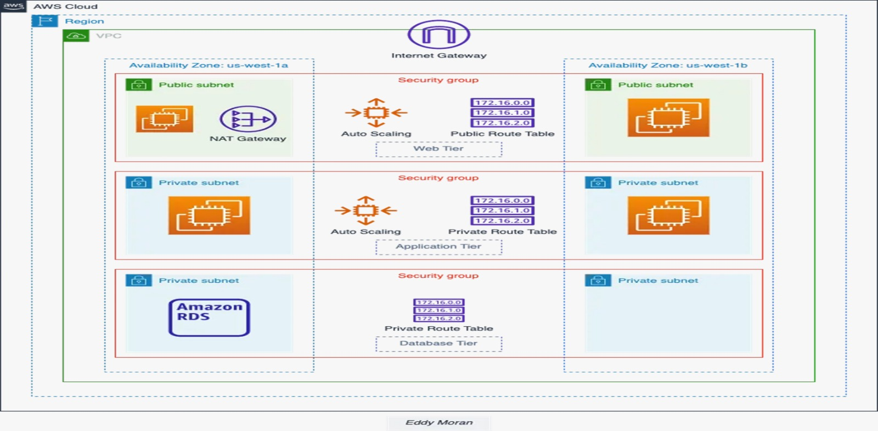

From this architecture we are having:

* **Virtual Private Cloud (VPC):**

A VPC is similar to a traditional network in terms of security and connectivity, but with the added benefits of AWS's scalability, reliability, and flexibility. It allows you to create your own virtual network within the AWS cloud, with complete control over network configuration.

A VPC provides a completely isolated virtual network environment, allowing you to create and manage your own virtual network topology, including subnets, routing tables, and network gateways.

**Key features in VPC**:

**1.Subnet**

* A subnet is a range of IP addresses in your VPC.
* You can create one or more subnets in your VPC, and each subnet can be associated with a different availability zone.
* This allows you to create highly available and fault-tolerant applications.

**2.Internet Gateway**

* An internet gateway allows your instances in the VPC to communicate with the internet.
* You can use an internet gateway to route traffic to and from the internet.

**3. NAT Gateway**

* A Network Address Translation (NAT) gateway allows your instances in private subnets to access the internet.
* NAT gateway enables instances in the private subnet to communicate with the internet while still maintaining security.

**4. Security Groups**

* Security groups act as a firewall for your instances.
* You can use security groups to control traffic to and from your instances.
* Each security group can be associated with one or more instances.

**5.Route Tables**

* In networking, a route table is a data structure that maps the destination addresses of packets to the next hop or outgoing interface.
* It is used by routers to determine the best path for forwarding traffic between networks.

**Step by step process:**

* **Creating VPC:**
* Sign in to AWS Management Console.
* Go to VPC dashboard and click on create VPC. In VPC settings, create only the VPC resource.
* Create a tag with a key of “Name” and a value that you specify.
* Select IPv4 CIDR manual input.
* Give the IPv4 CIDR as 10.0.0.0/16. This IP address range includes all addresses from 10.0.0.0 to 10.255.255.255, and the subnet mask for this range is 255.255.0.0. The 10.0.0.0/16 subnet can accommodate up to 65,536 host addresses, making it suitable for larger networks.
* Click on create VPC.

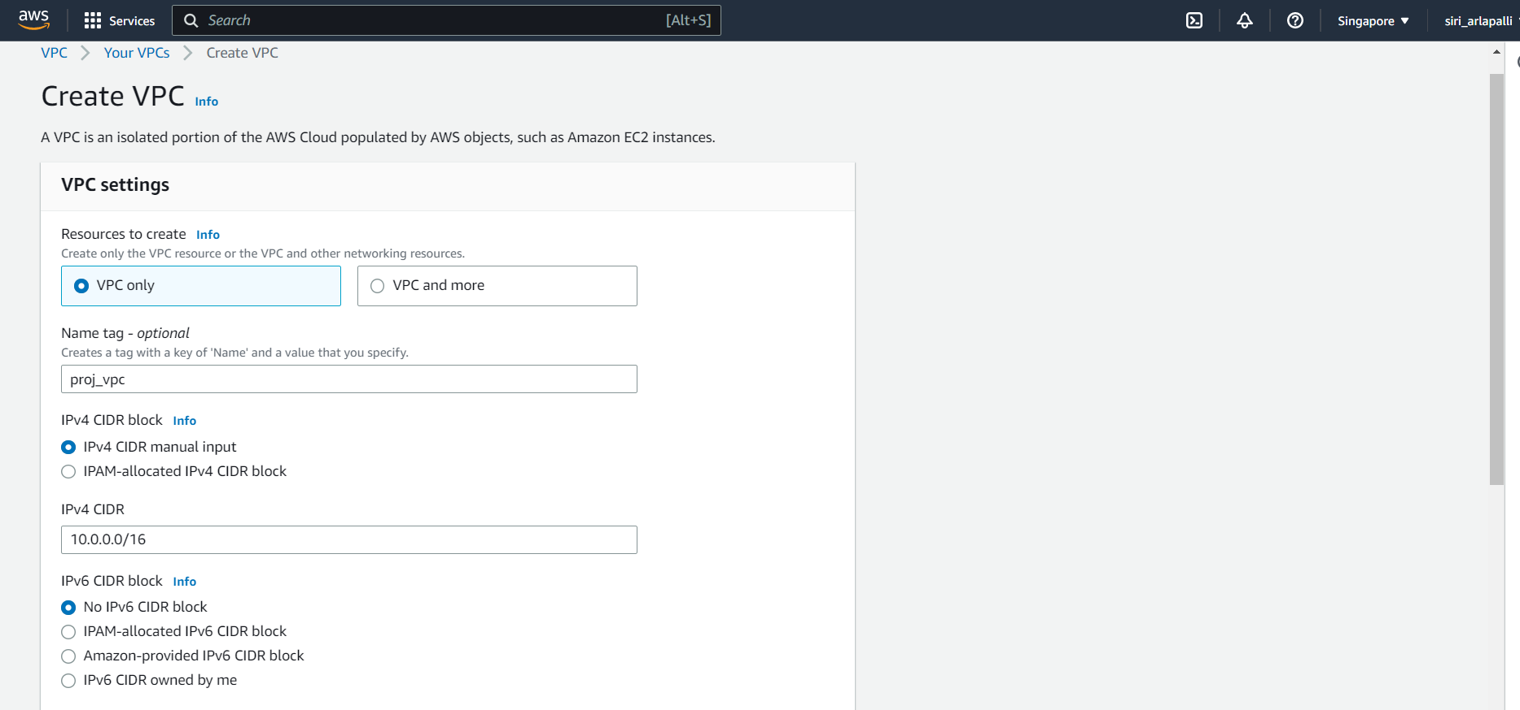

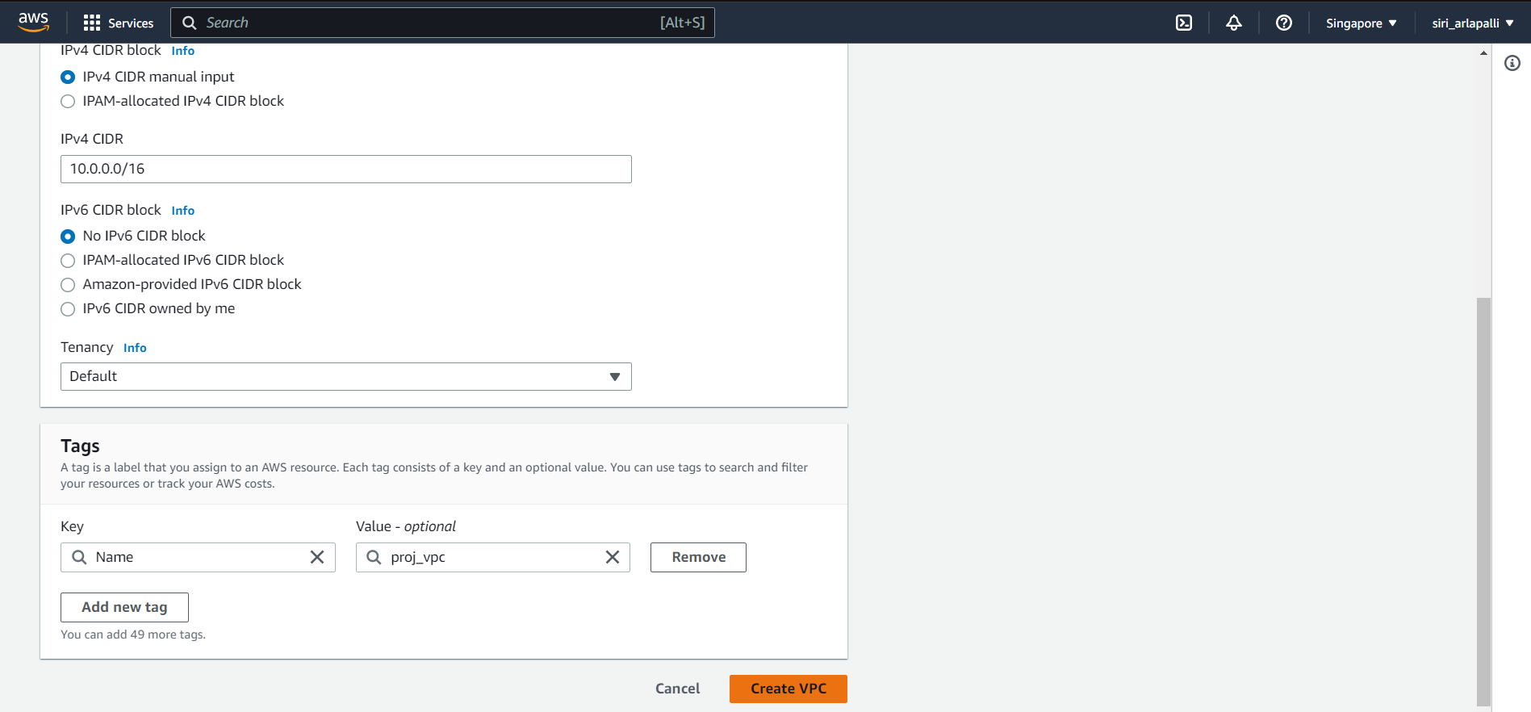

* **Creating subnet:**
* Select the VPC that we created earlier to create a public subnet. In the subnet settings give the subnet name and choose ap-southeast-1a in Singapore region.
* Give the IPv4 CIDR as 10.0.1.0/24. Click on add subnet. Create 2 more private subnets one in same availability zone as public subnet and the other in another availability zone. Click on create subnets.

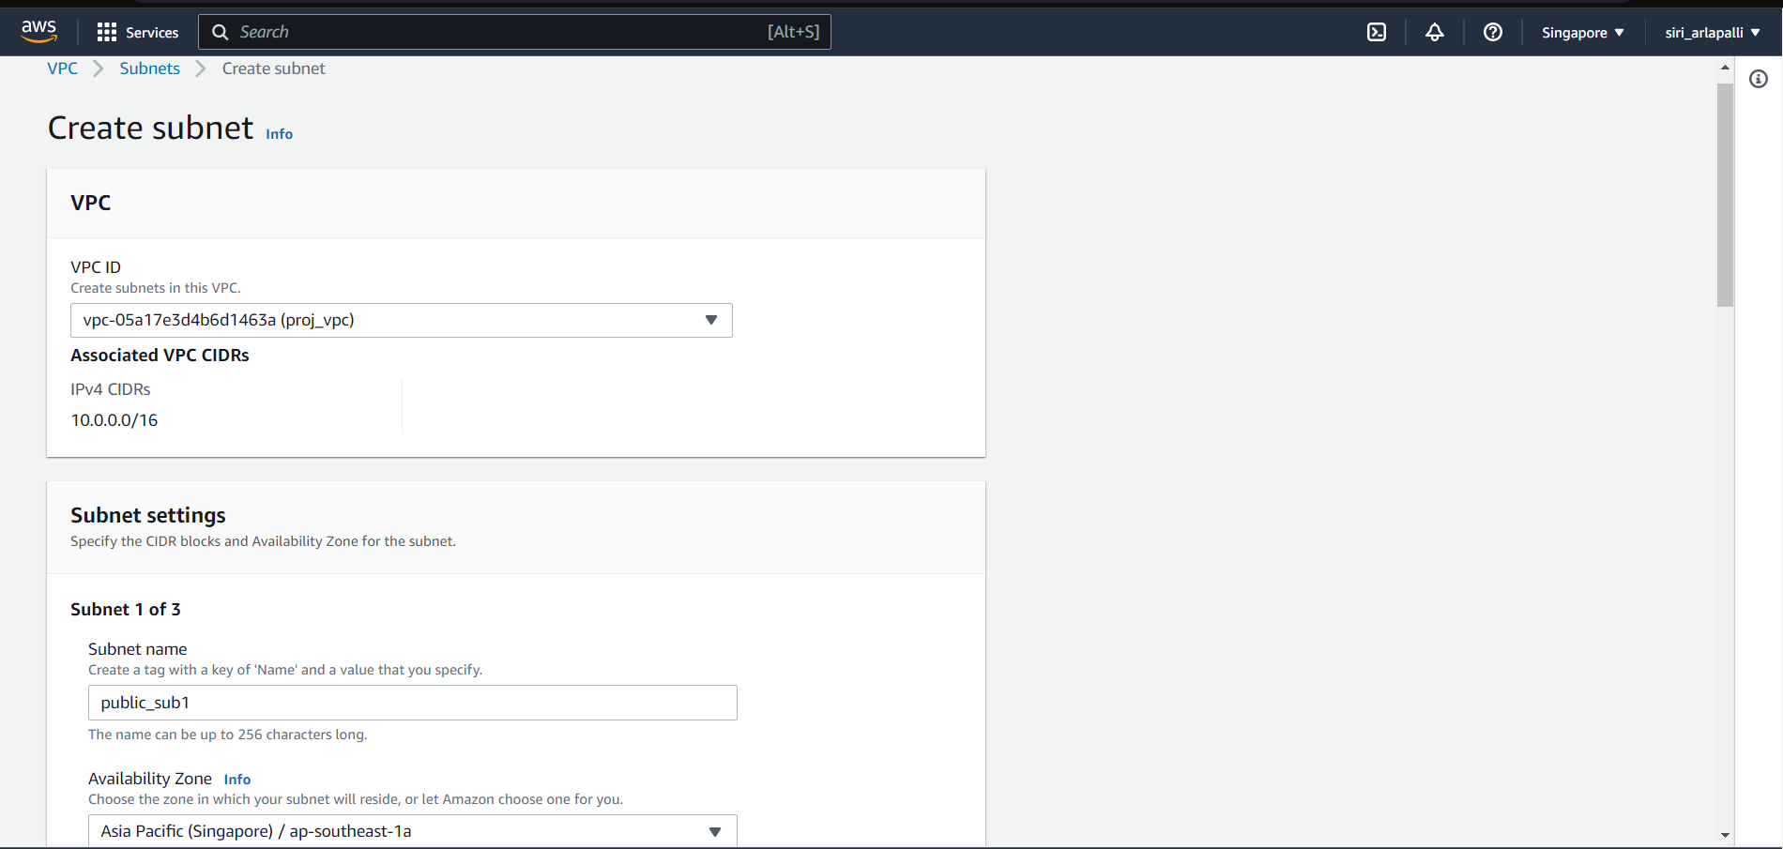

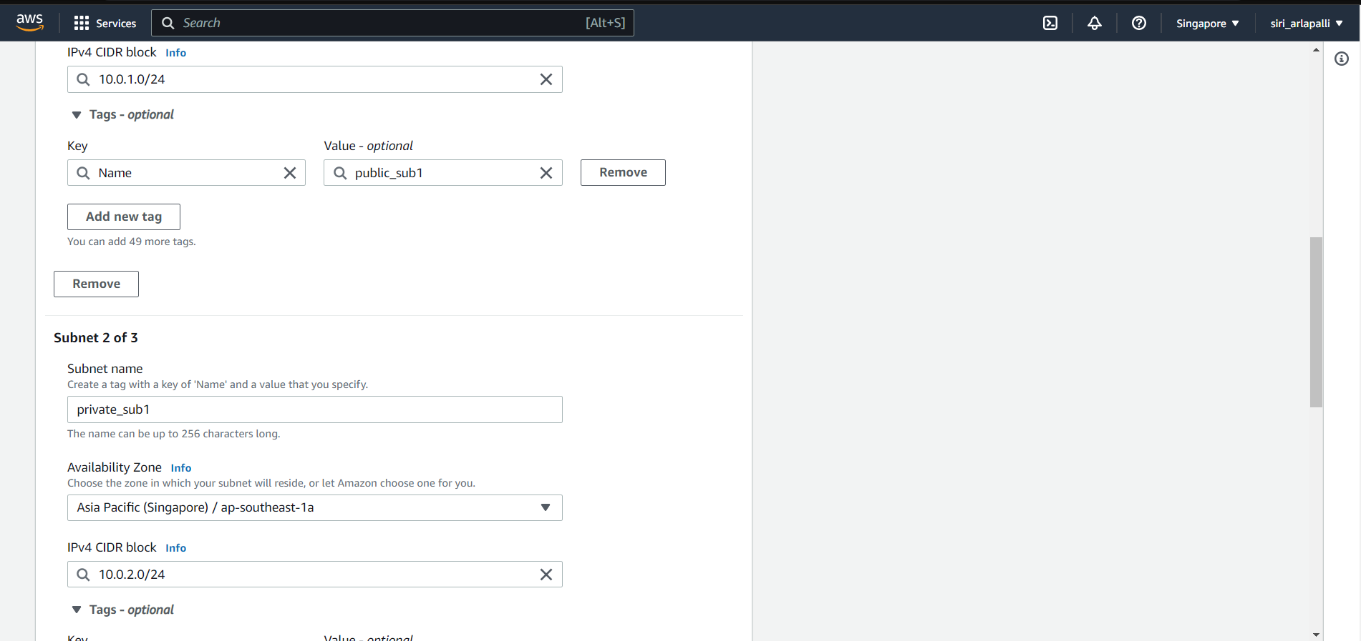

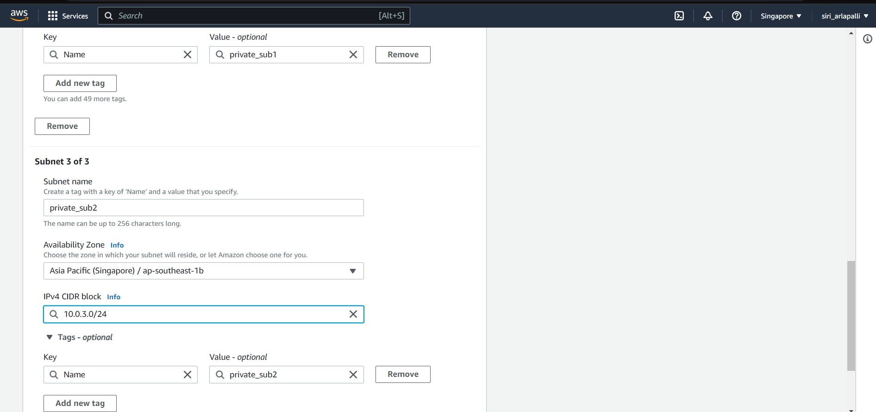

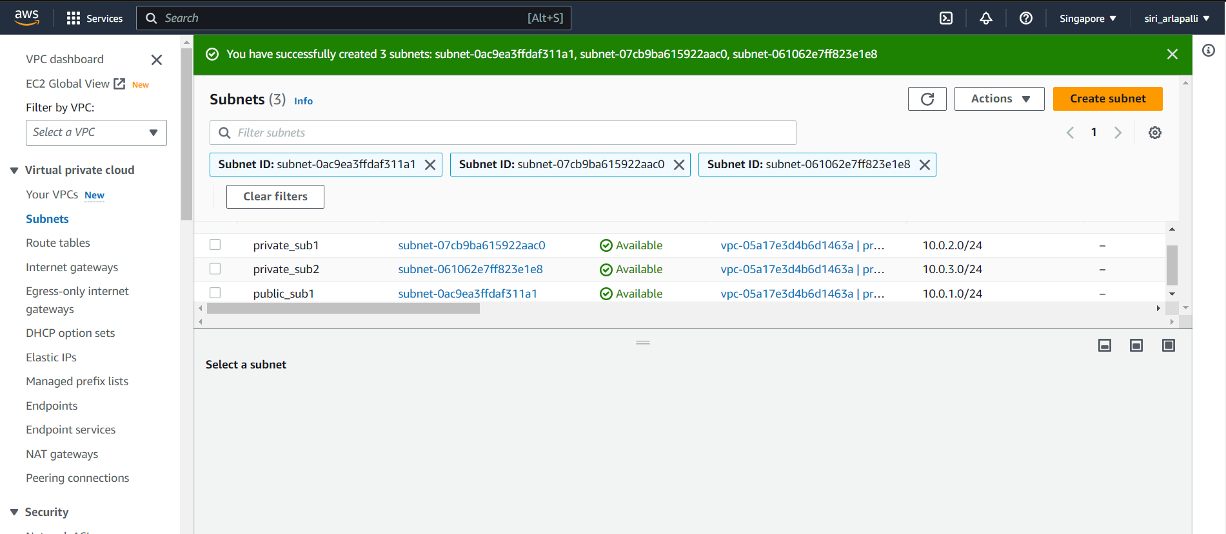

* **Creating Internet Gateway (IGW):**
* An internet gateway is a virtual router that connects a VPC to the internet.
* To create a new IGW specify the name for the gateway.

Click on create IGW.

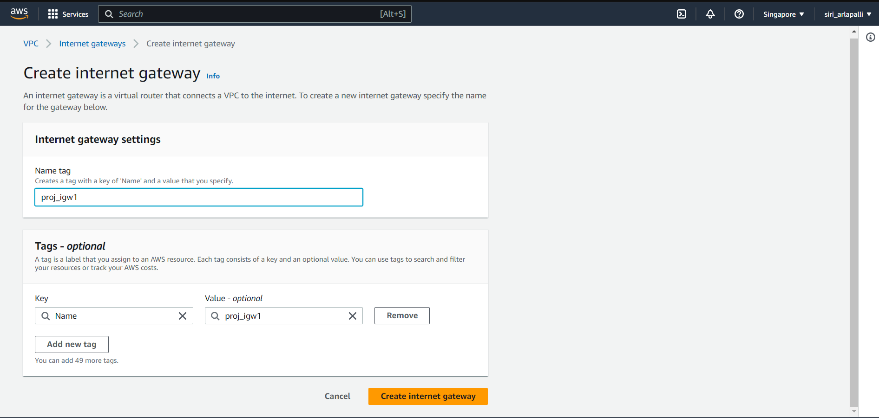

* Click on Attach VPC and select the VPC that we have created earlier.

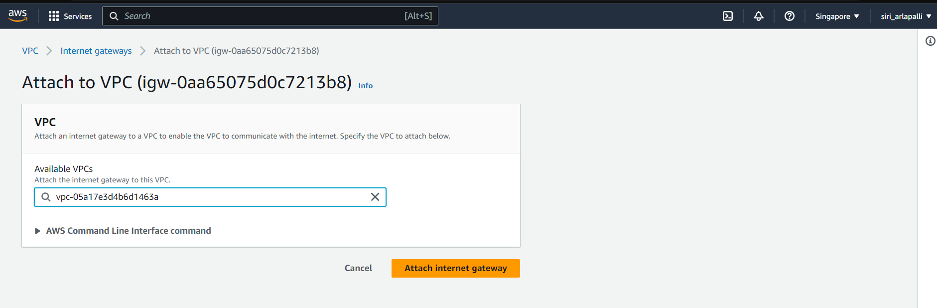

* **Creating Network Address Translation (NAT) Gateway:**
* A highly available, managed NAT service that instances in private subnets can use to connect to service in other VPC’s , on premises networks, or the internet.
* In NAT gateway settings, give the name and select the public subnet.
* Allocate elastic IP address to the NAT gateway.

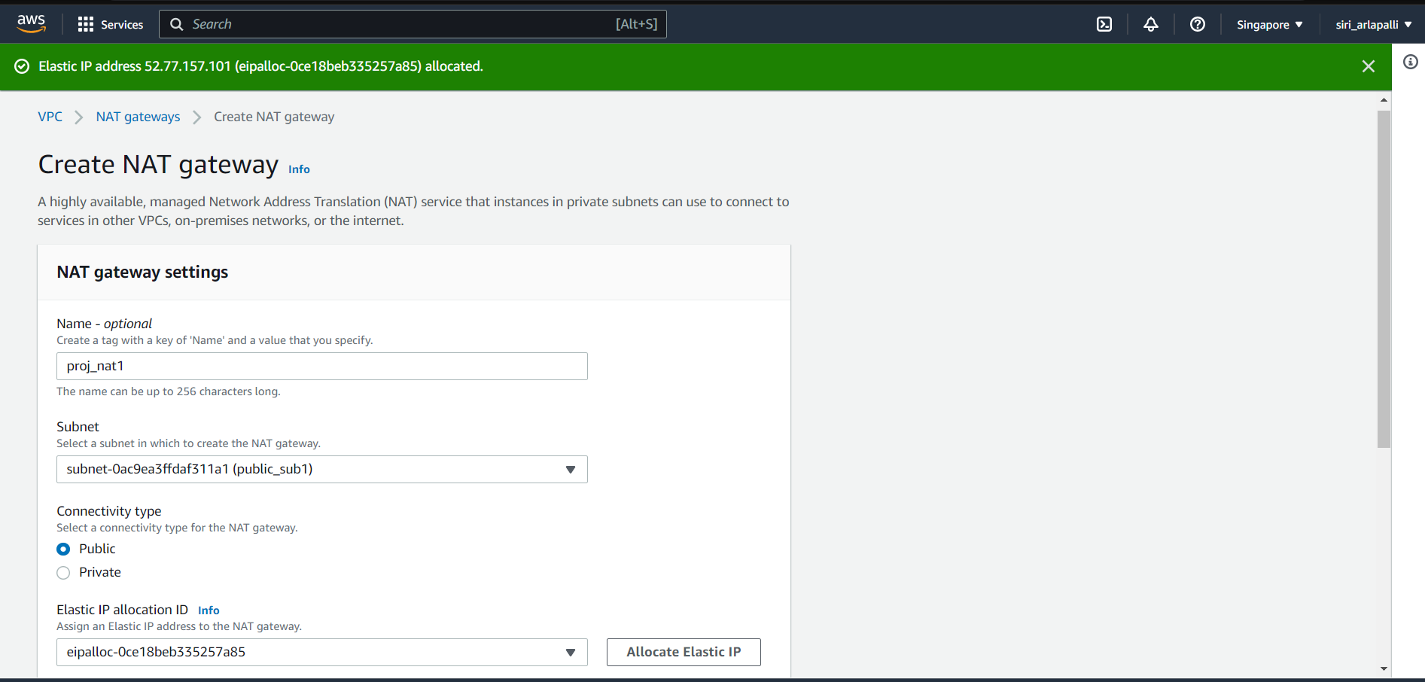

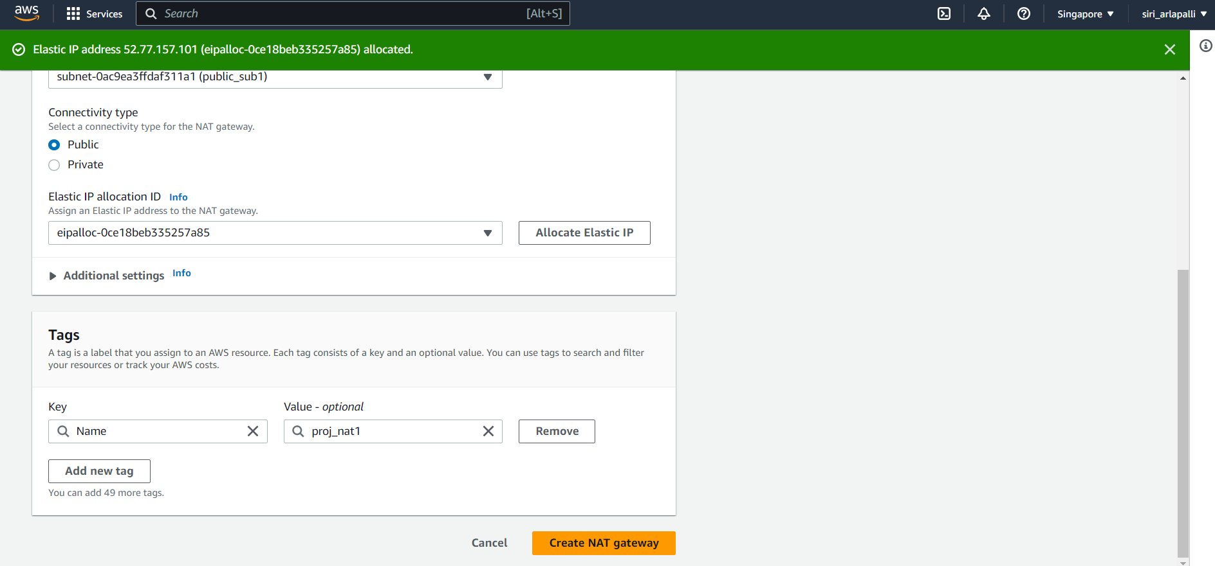

* **Creating Route Table**
* A routetable specifies how packets are forwarded between the subnets within your VPC, the internet, and your VPN connection.
* In route table settings, create a public route table by giving the name and select the VPC that was created earlier. Click on create route table.

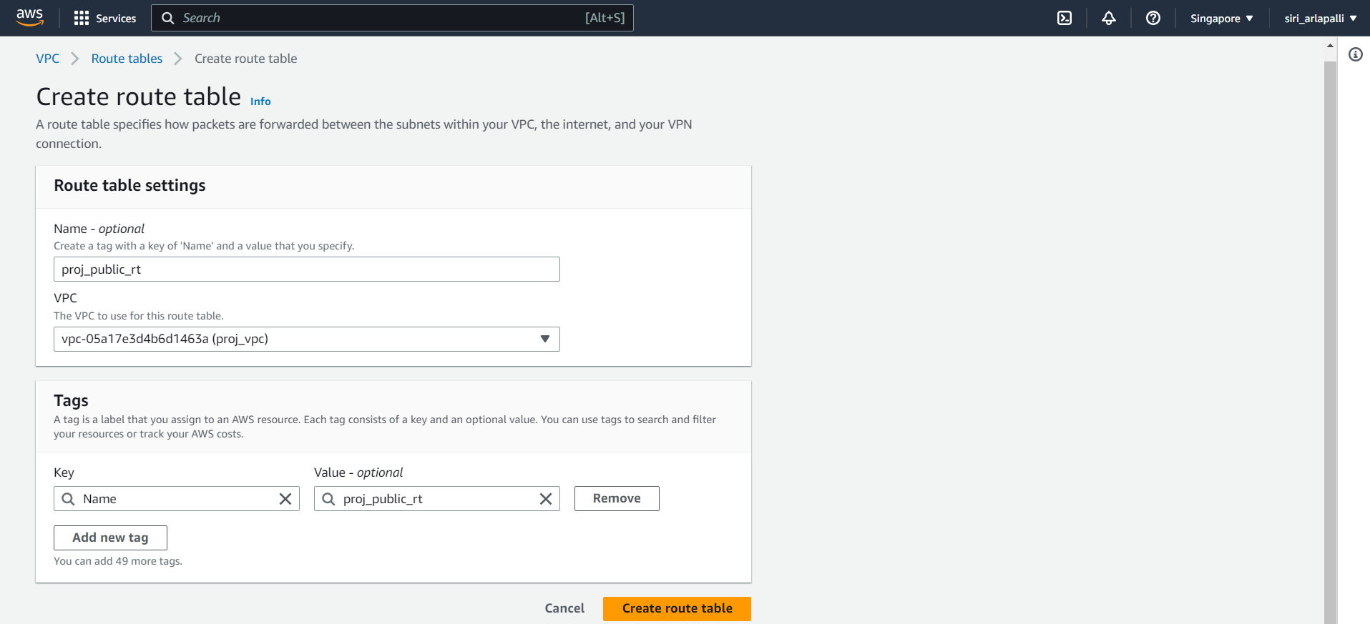

* Click on create route table, In route table settings, create a private route table by giving the name and select the VPC that was created earlier. Click on create route table.

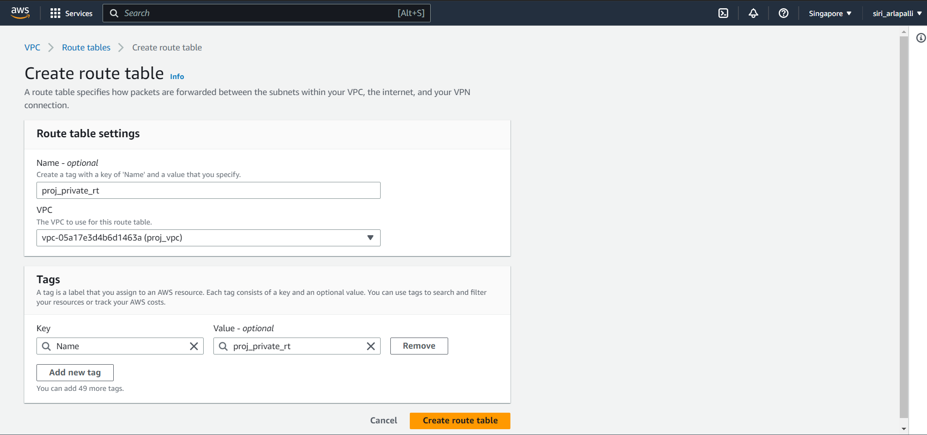

* Select the public route table and edit the routes by adding the internet gateway as target and destination is 0.0.0.0/0

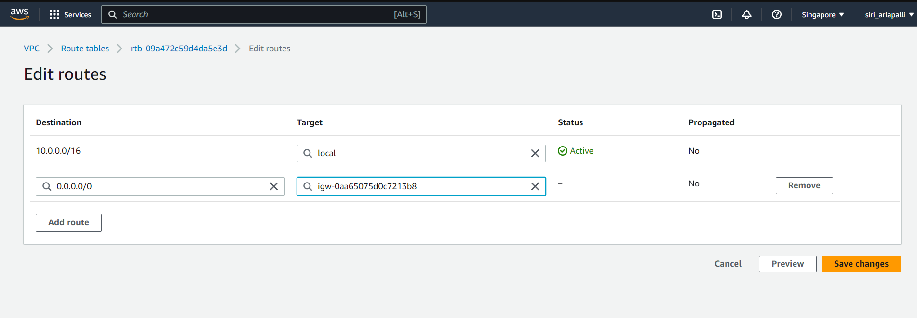

* Select the public route table and edit the subnet associations , add the public subnet. Click on save associations.

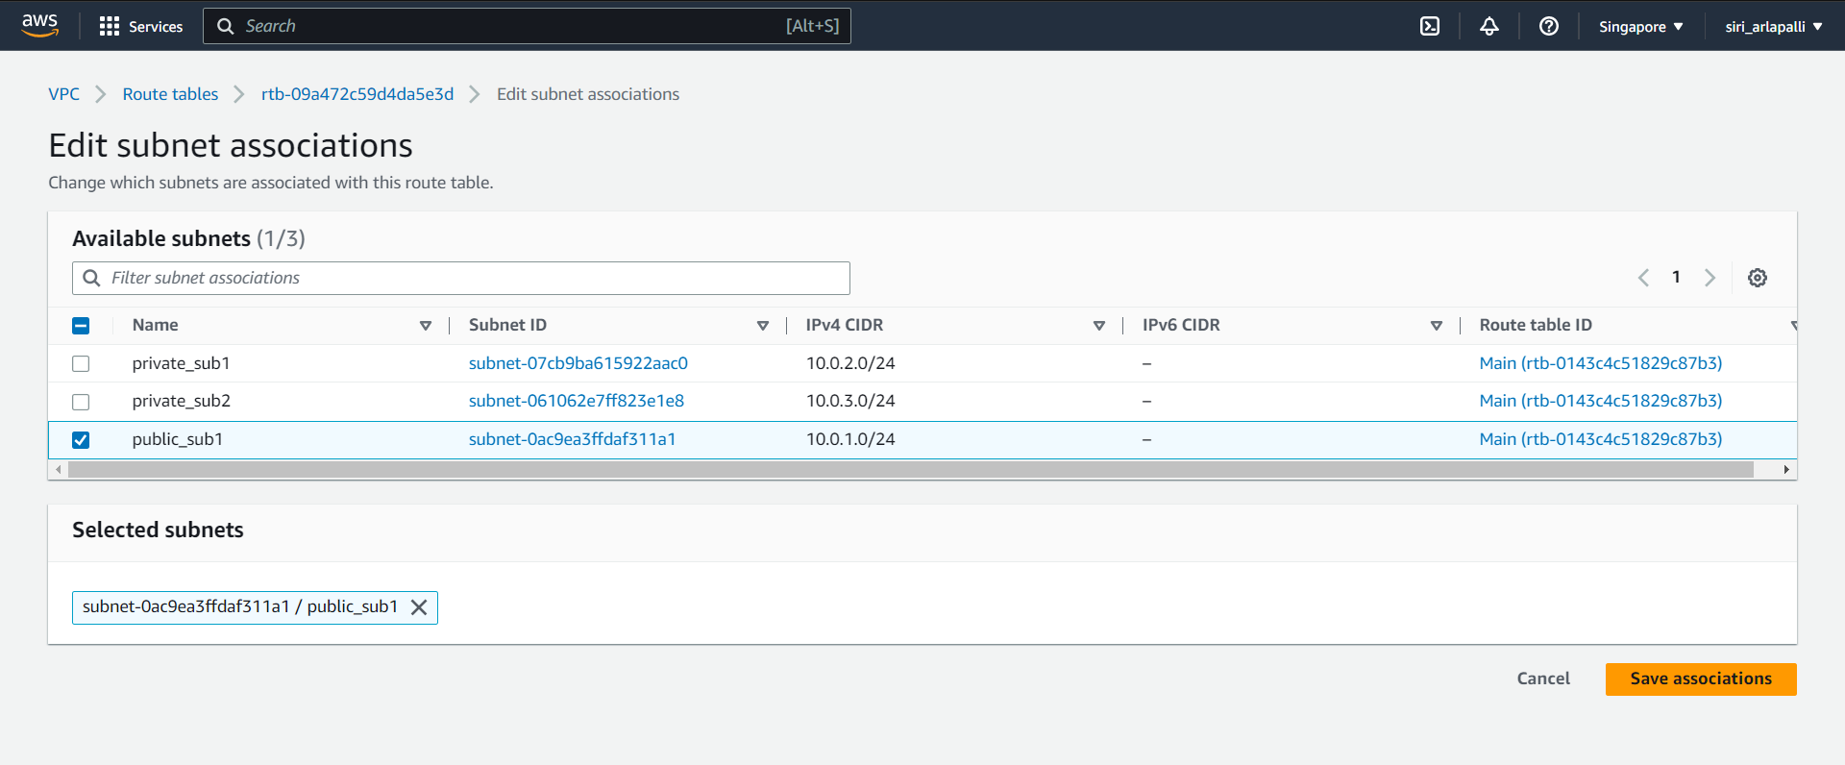

* Select the private route table ,and edit the routes , add the nat gateway to allow internet access.

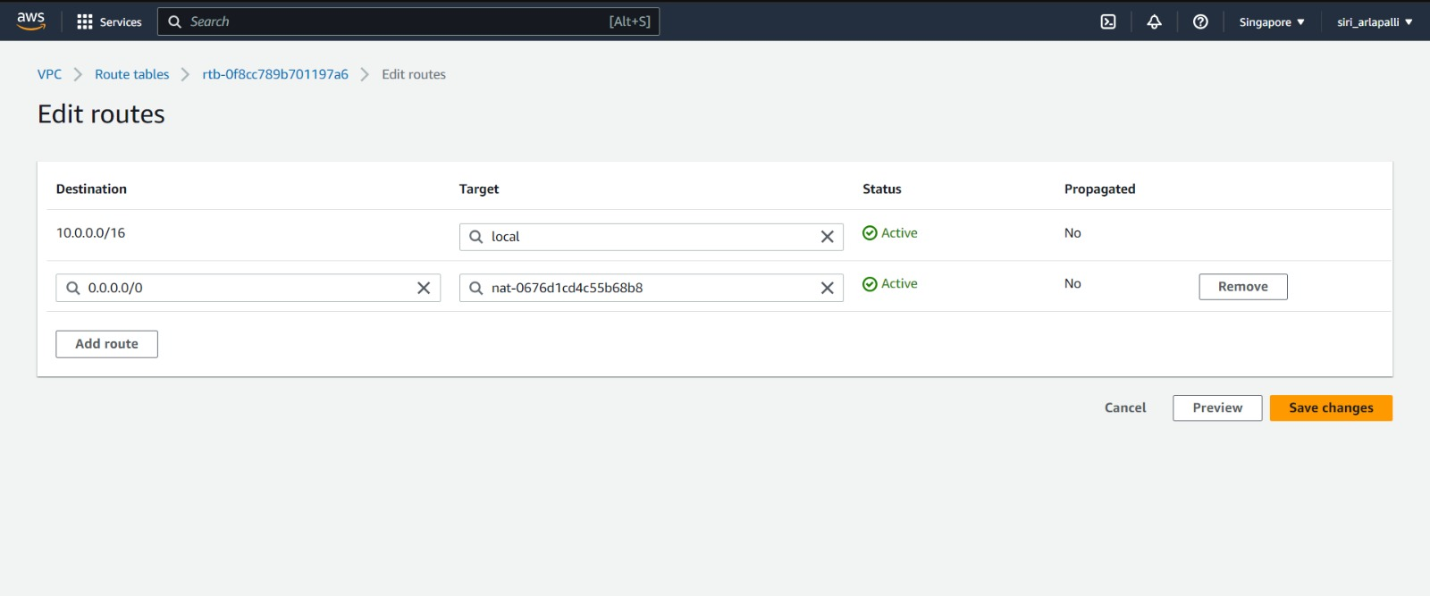

* Select the private route table and go to subnet associations and associate the private subnets , click on save associations.

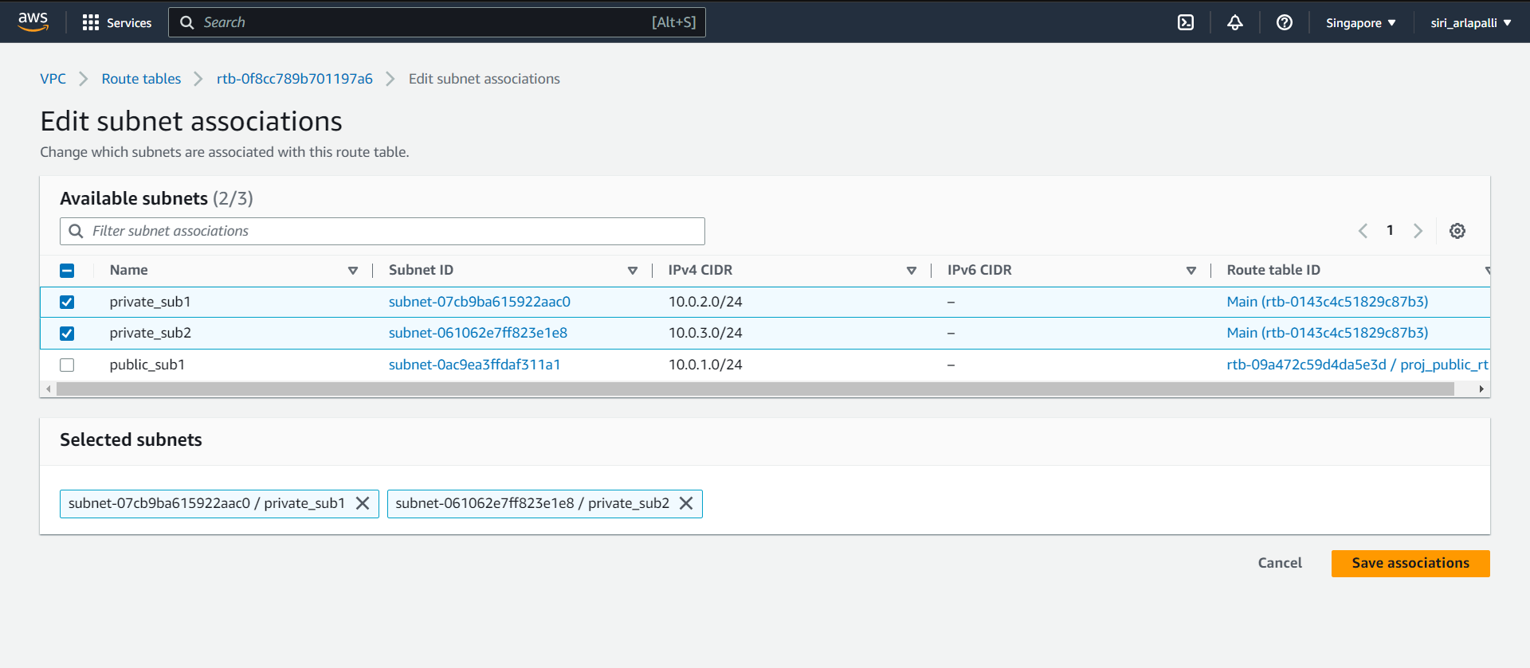

* **Creating EC2 instances**
* Go to the EC2 dashboard and create the instances.
* In the application tier , we have to launch the EC2 instance to deploy the web application.
* Create a public instance and give the name of as proj_public_server and select the ubuntu image.
* Create a new keypair.
* In the network settings , select the VPC that you have created and also select public subnet .
* Create the security group , the inbound rules should include the ssh to connect to the instance, http and https to request the query and get the response in web application.
* Create the instance.

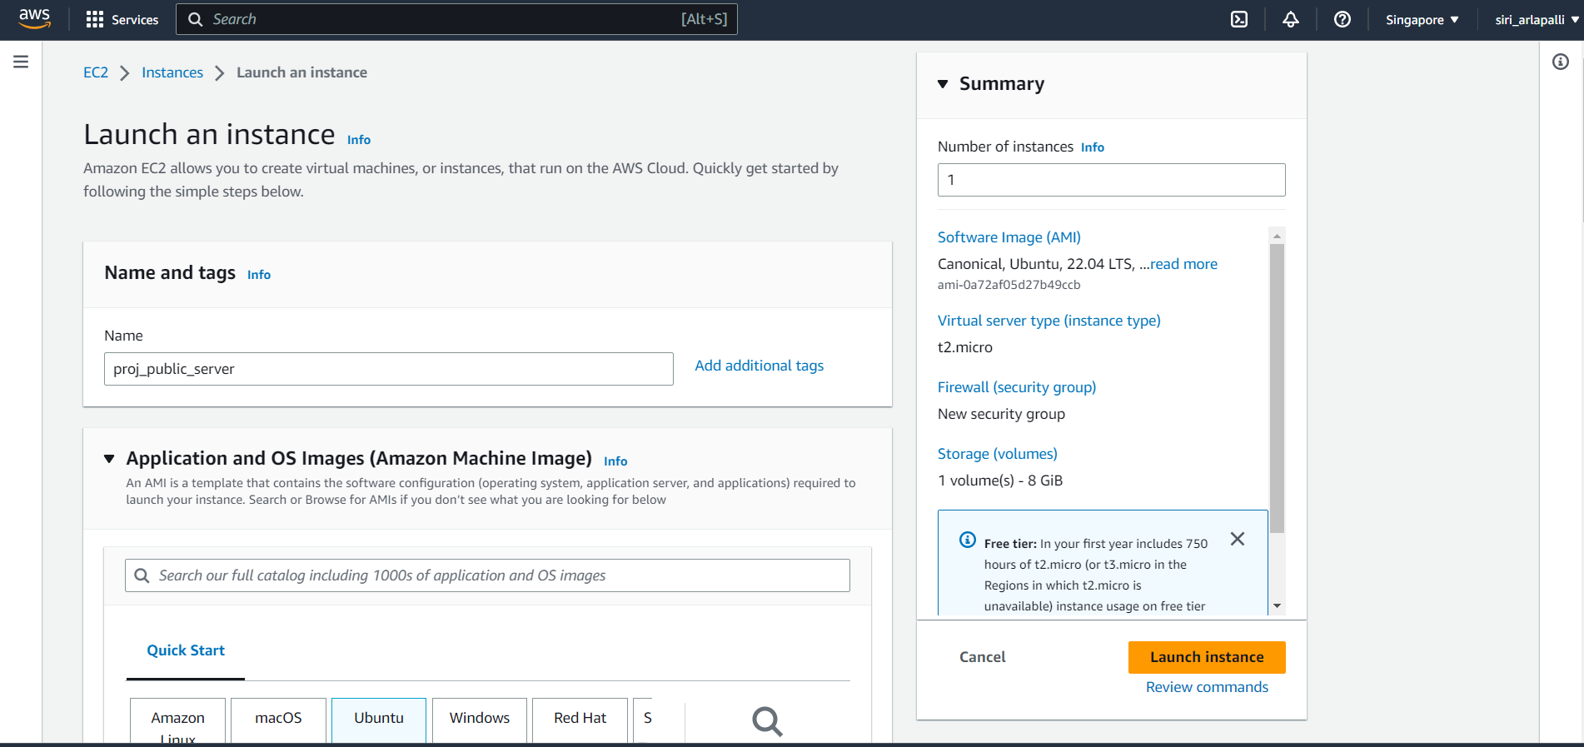

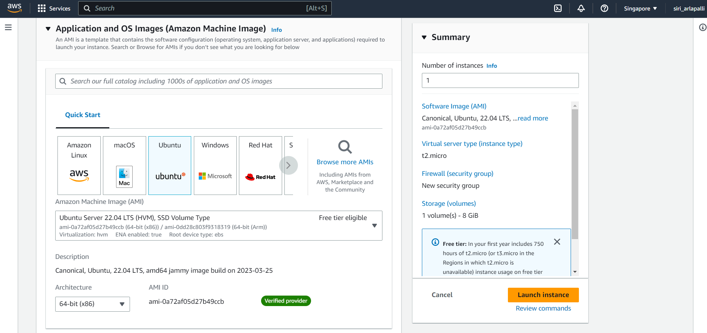

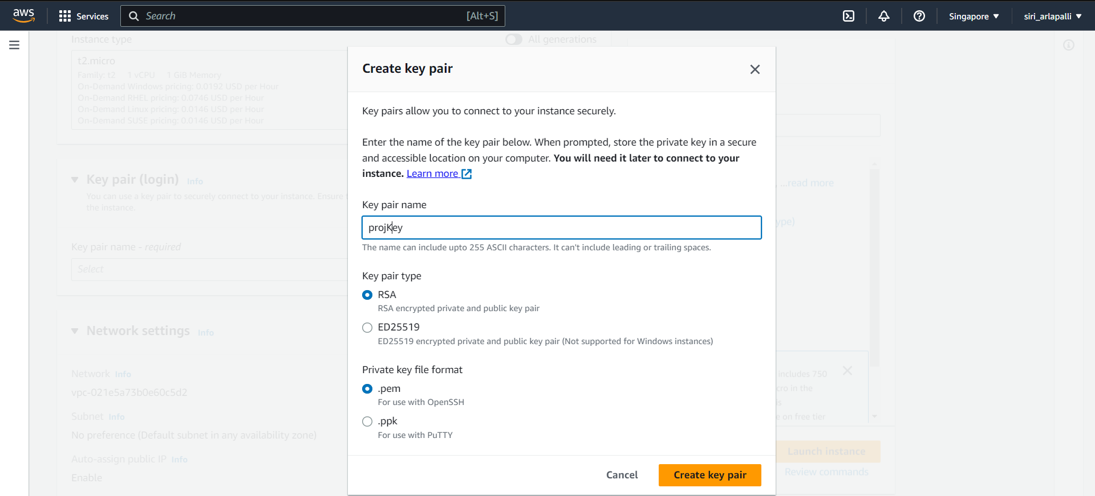

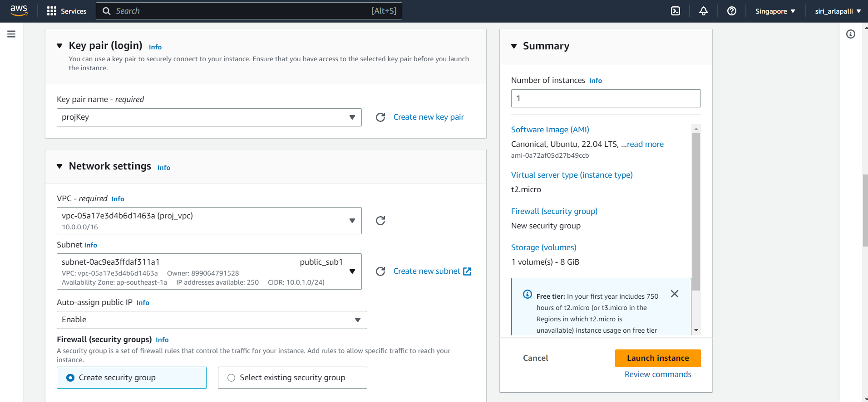

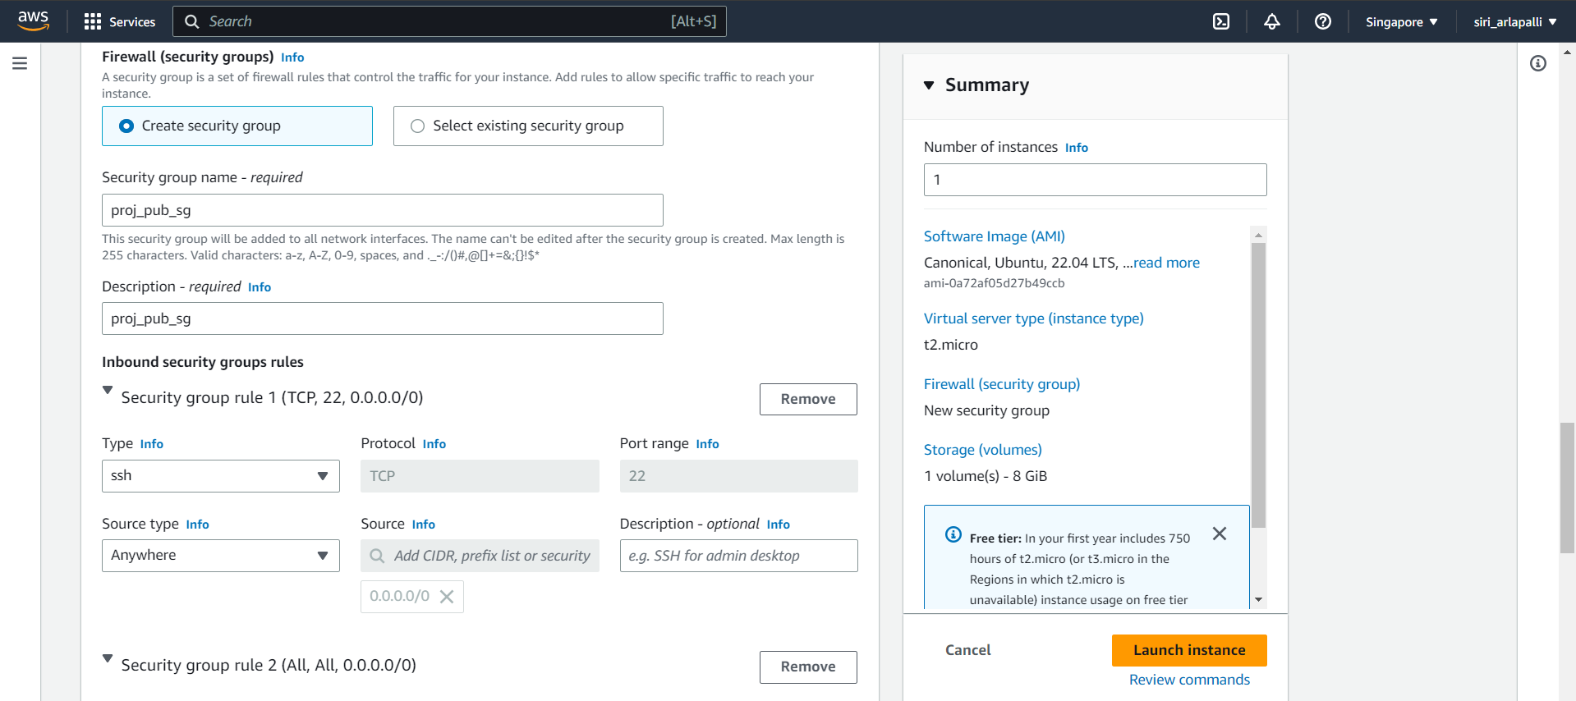

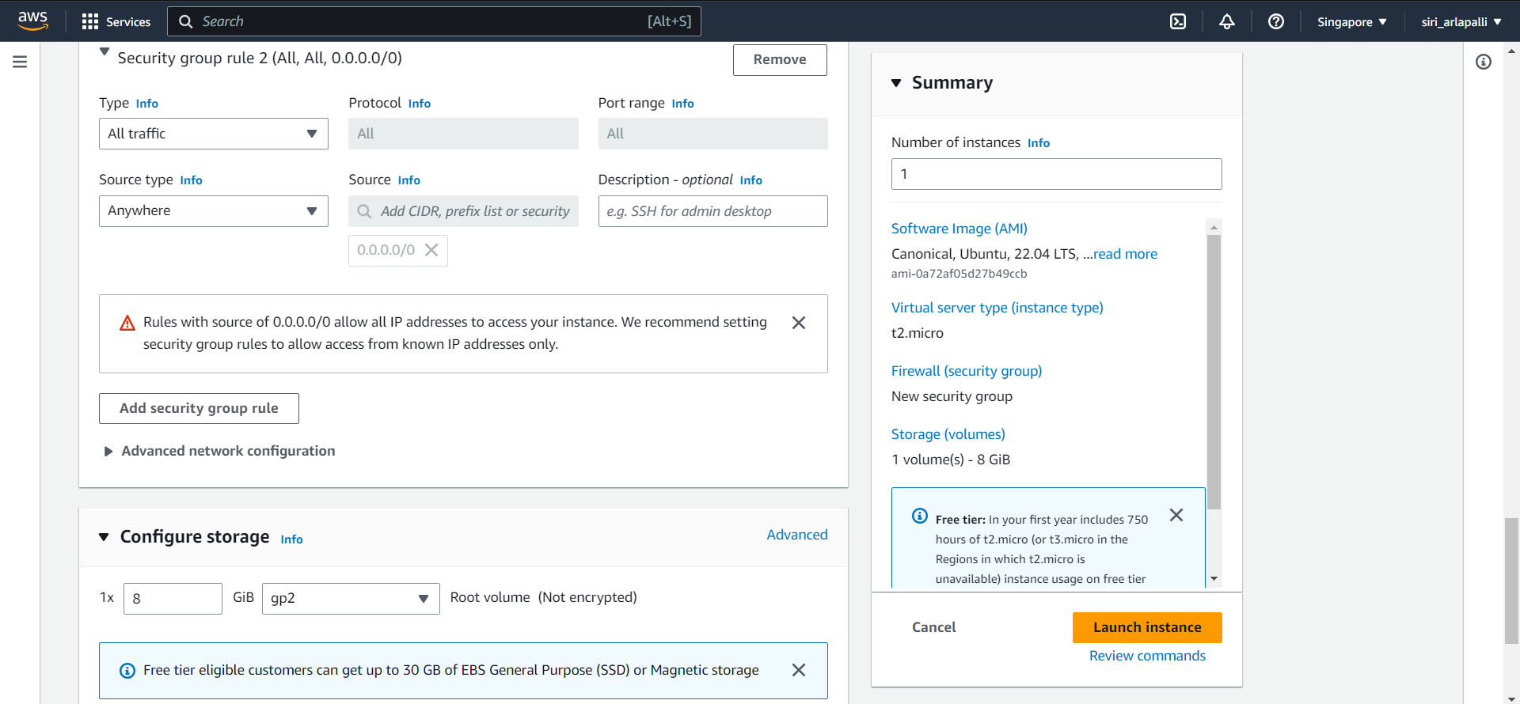

* Create another instance and make it private , because we should not give the public access to the Database that we would connect in further step.
* Give the name for the private instance and select ubuntu , select the existing key pair.
* In the network settings, select the VPC that you have created earlier and select the public subnet
* Create the new security group, it should include mysql inbound rule to communicate with database tier and include the ssh rule from the public server security group as source.Include the HTTP inbound rule to resend the response from database tier to the presentation tier.

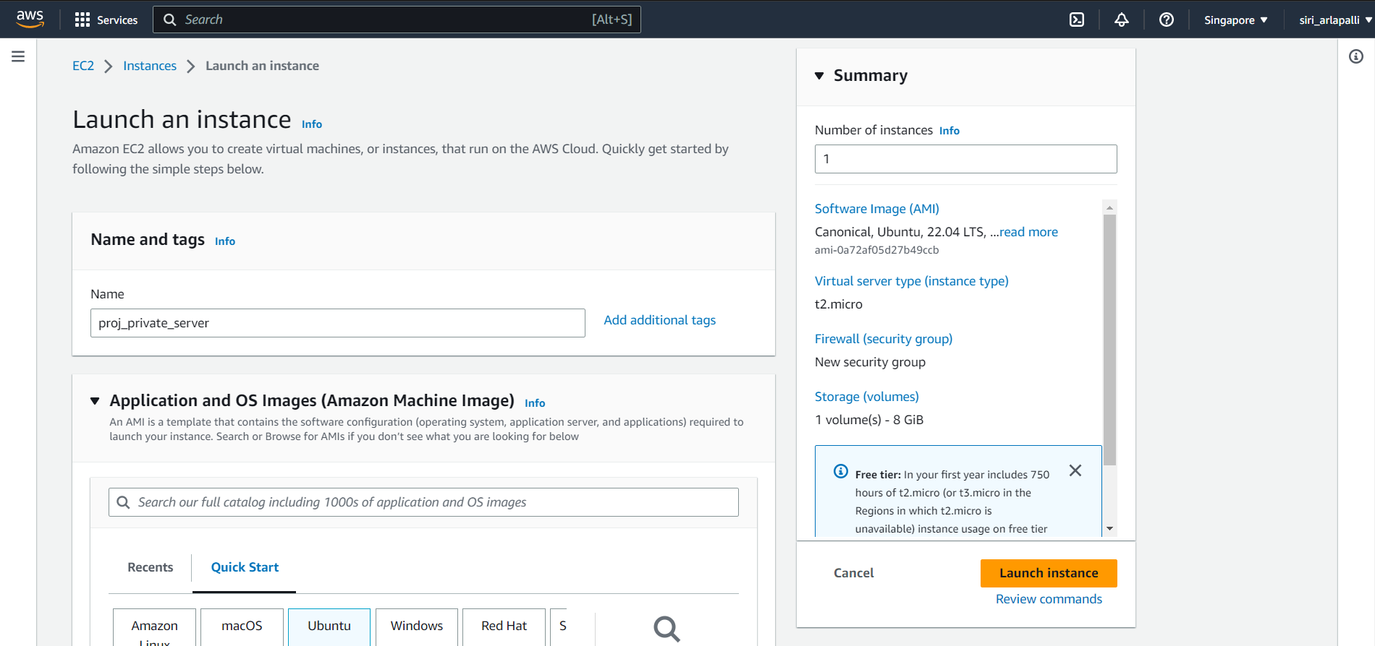

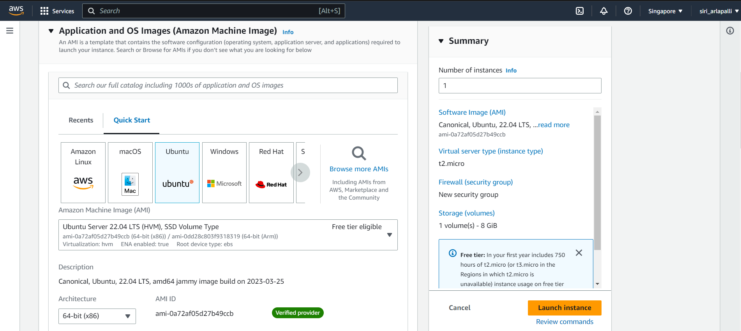

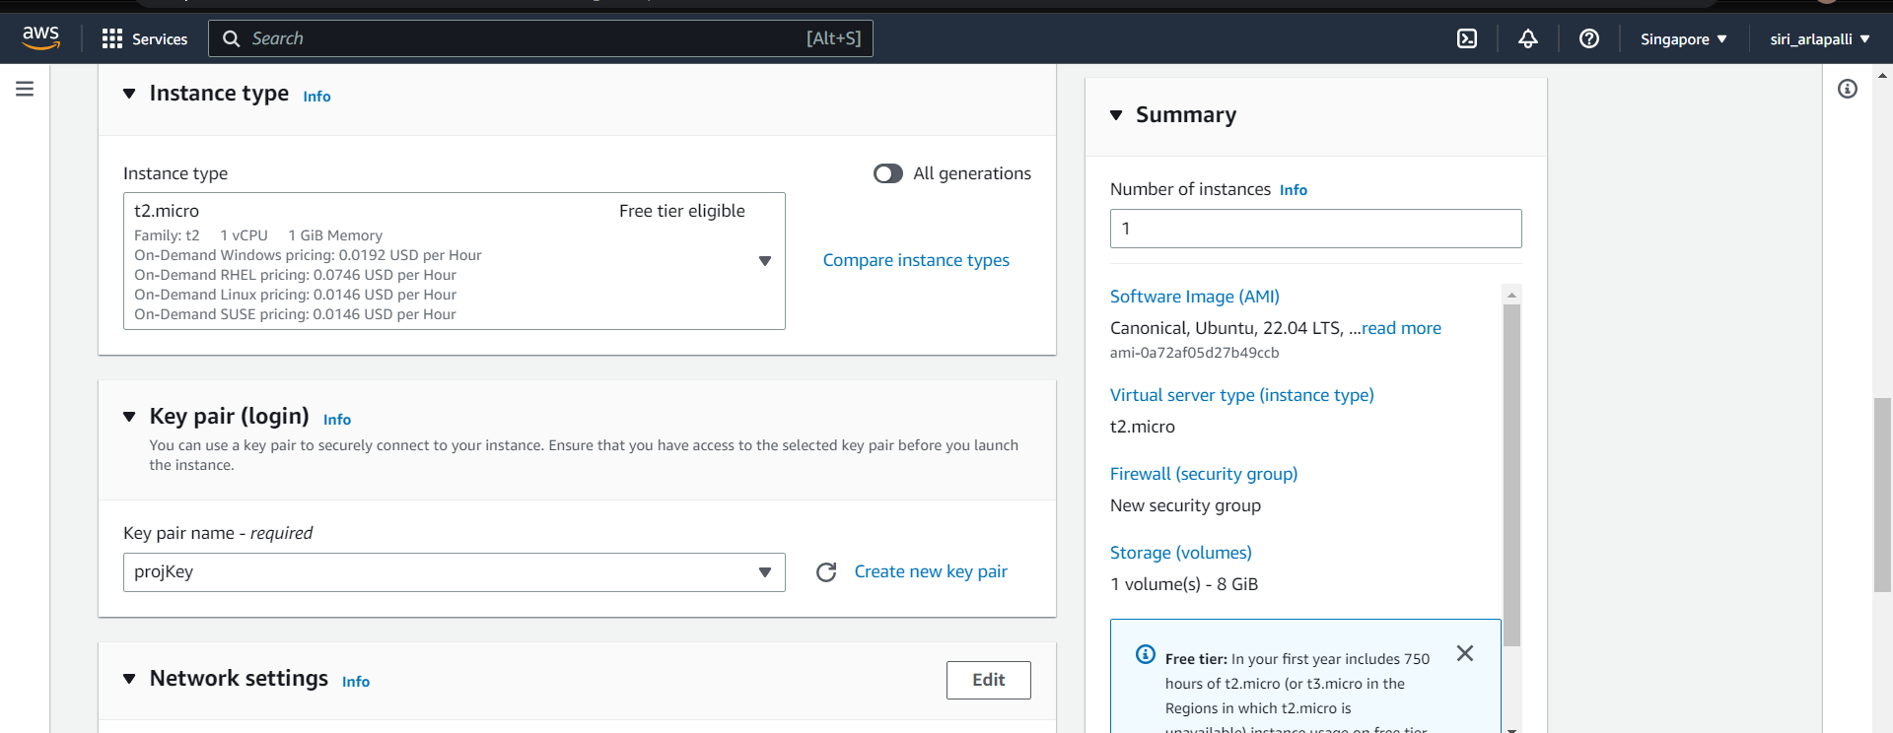

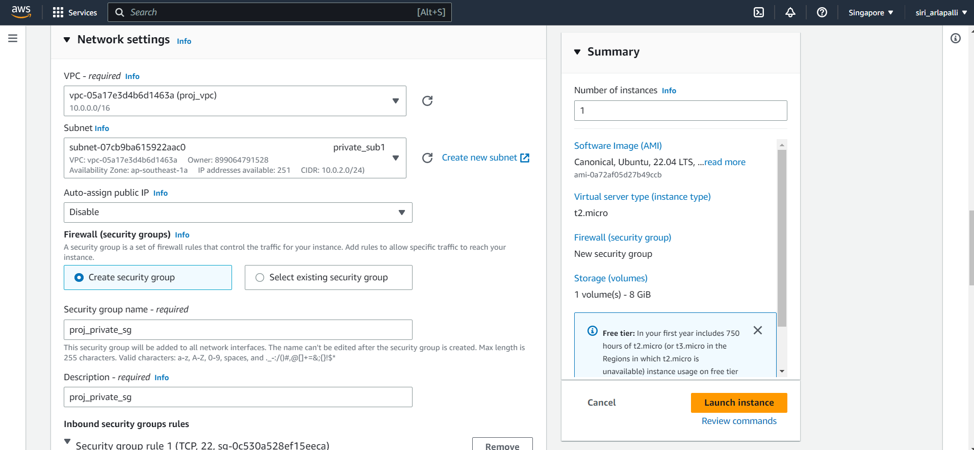

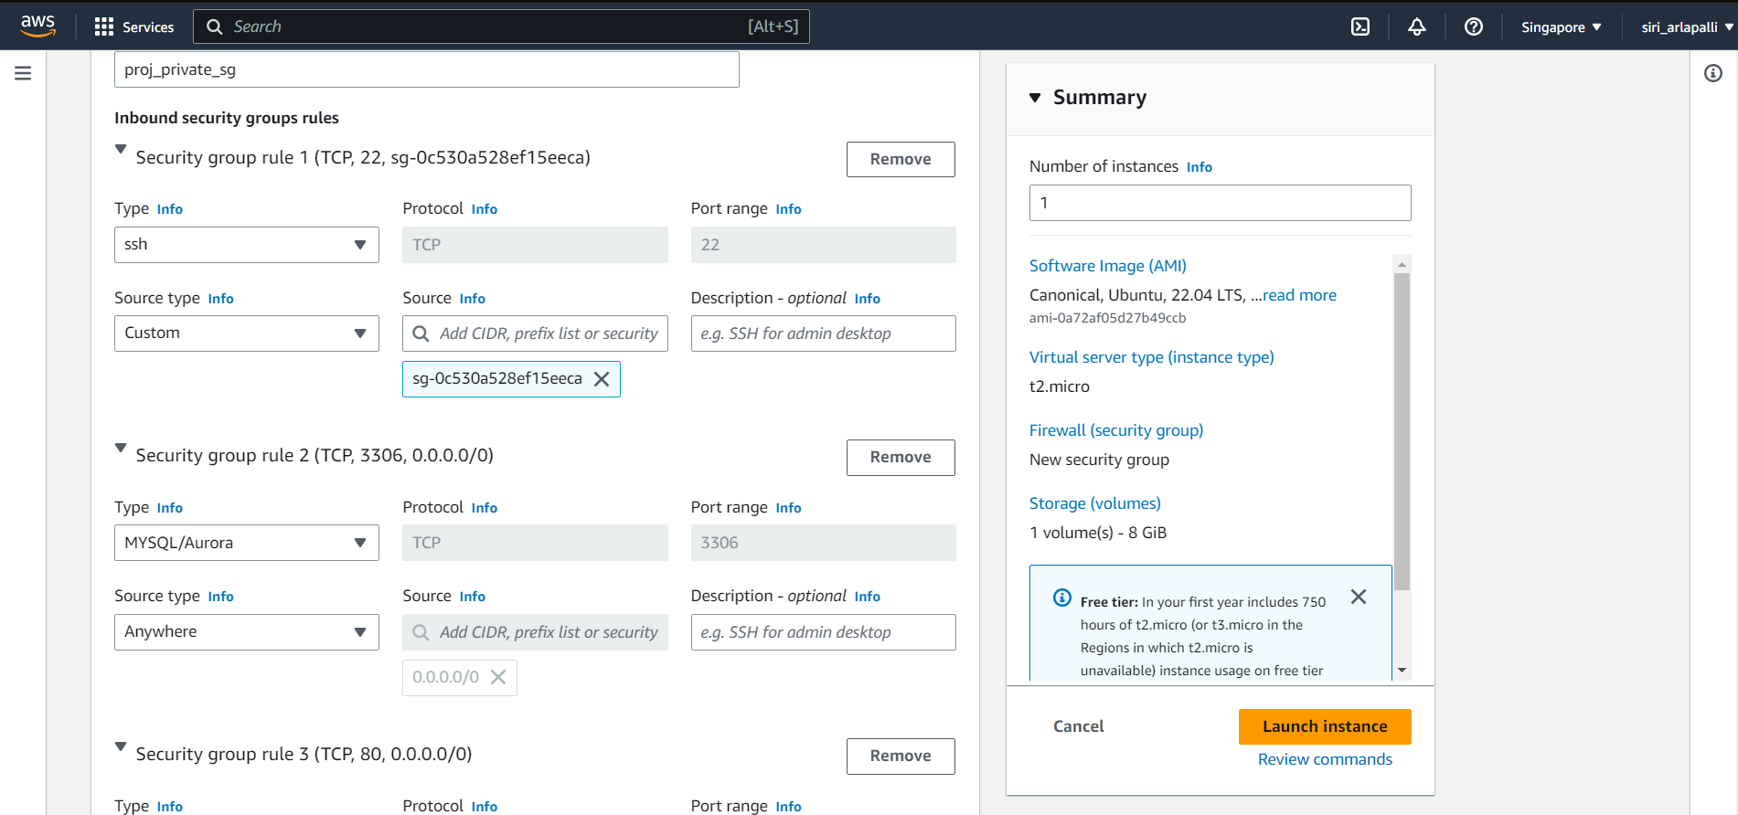

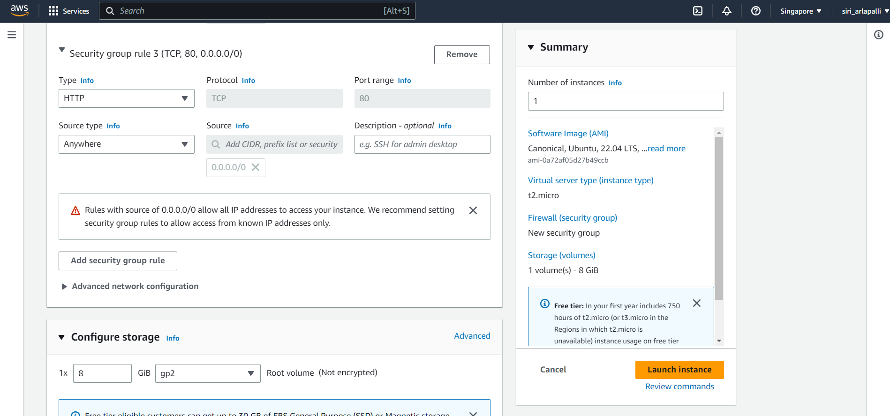

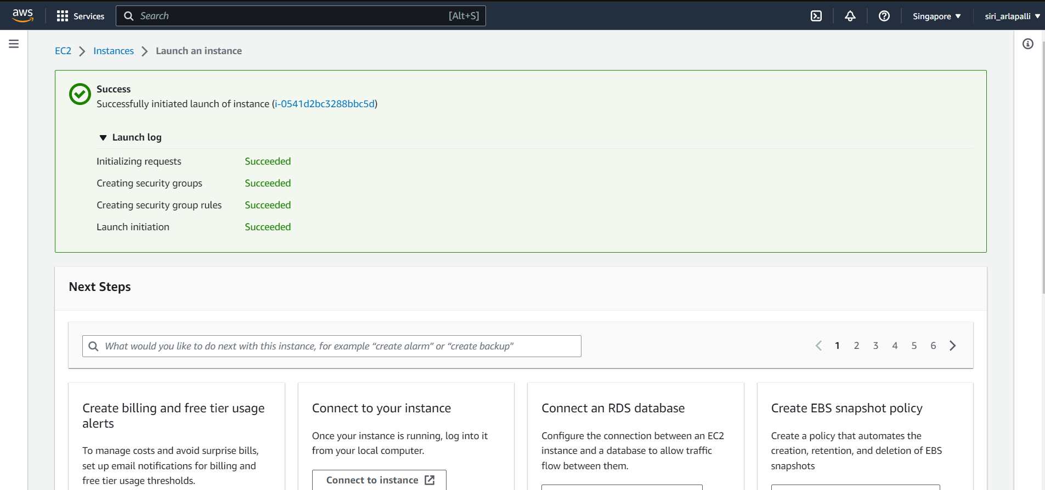

* **Creating the Database**
* Go to RDS
* Click on create database.
* Choose the standard create , that means you set all of the configurations options, including ones for availability , security, backups, and maintainance.
* Choose the MySQL engine option.
* Choose the free tier template to develop the application.
* In settings, give the name for the DB instance.
* Give the master username for the database and give the password to login to mysql database.

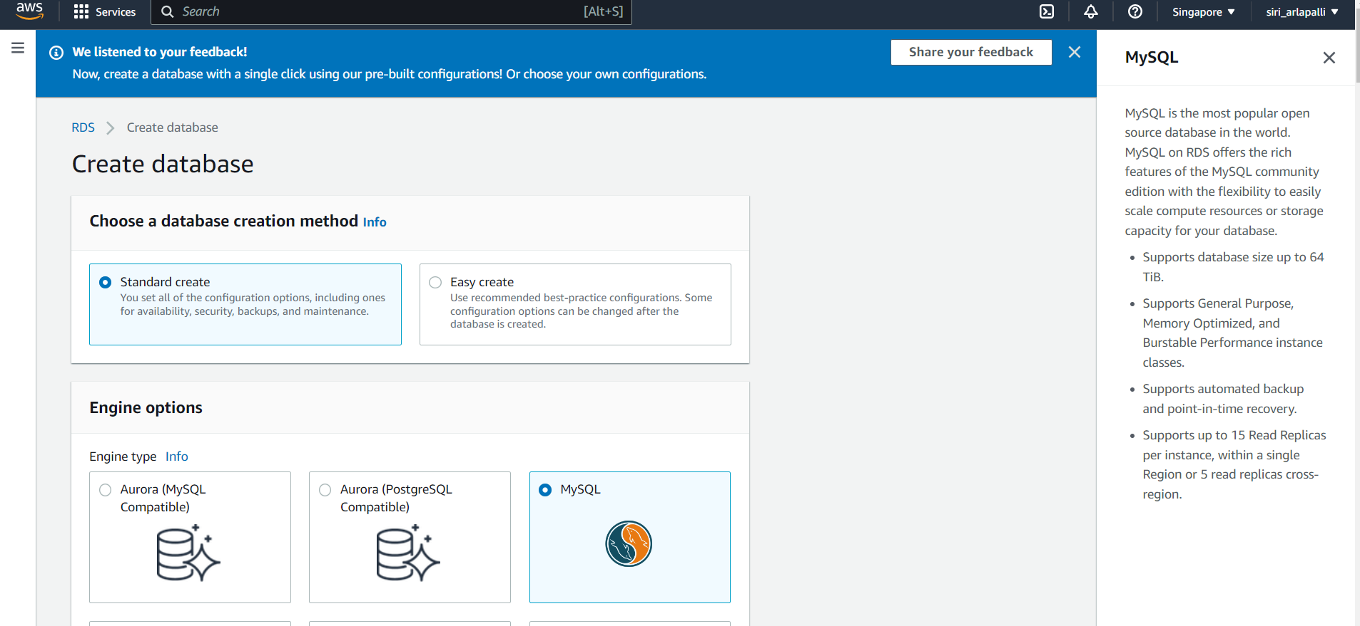

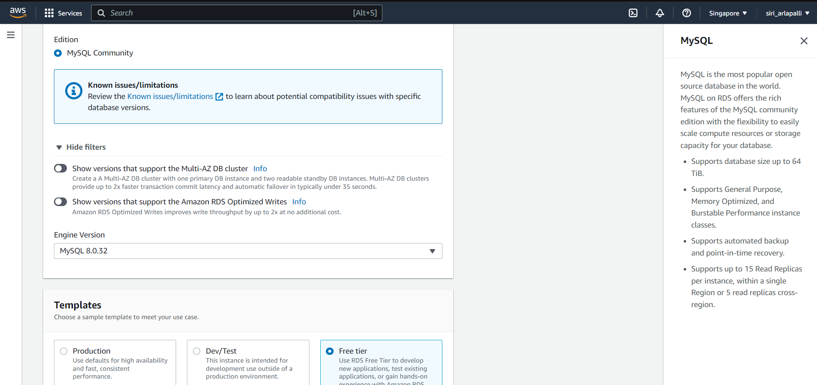

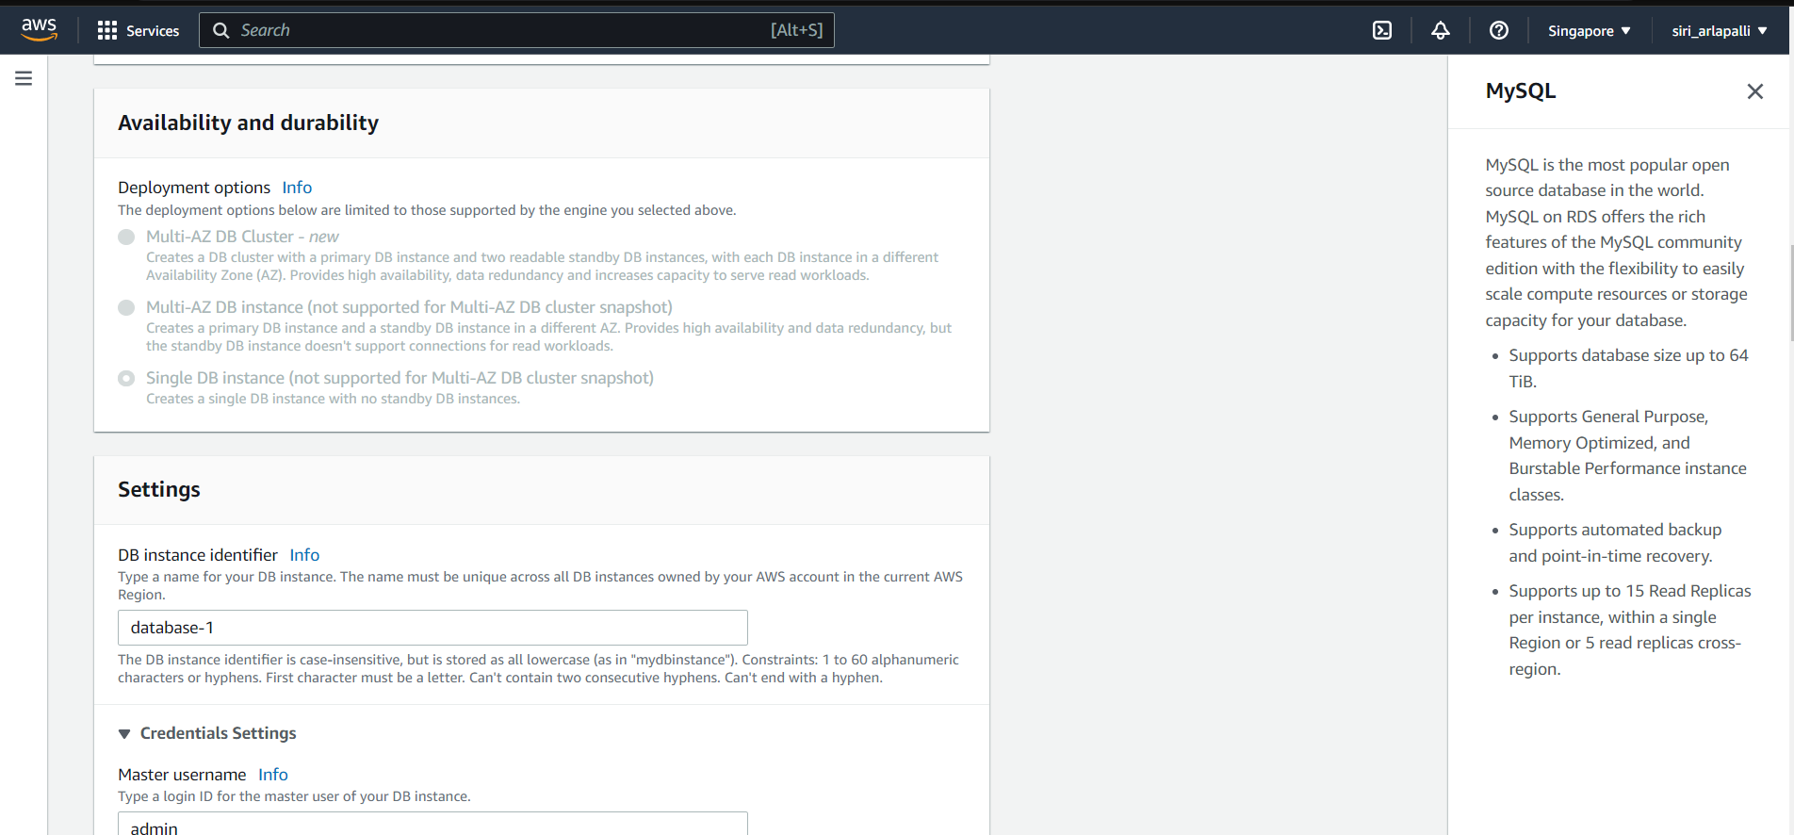

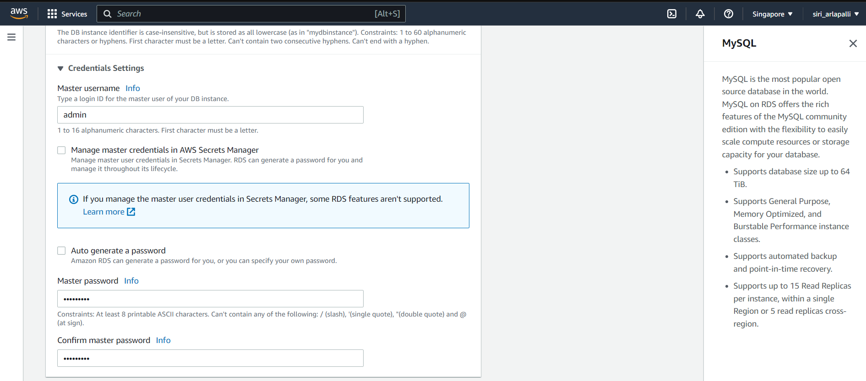

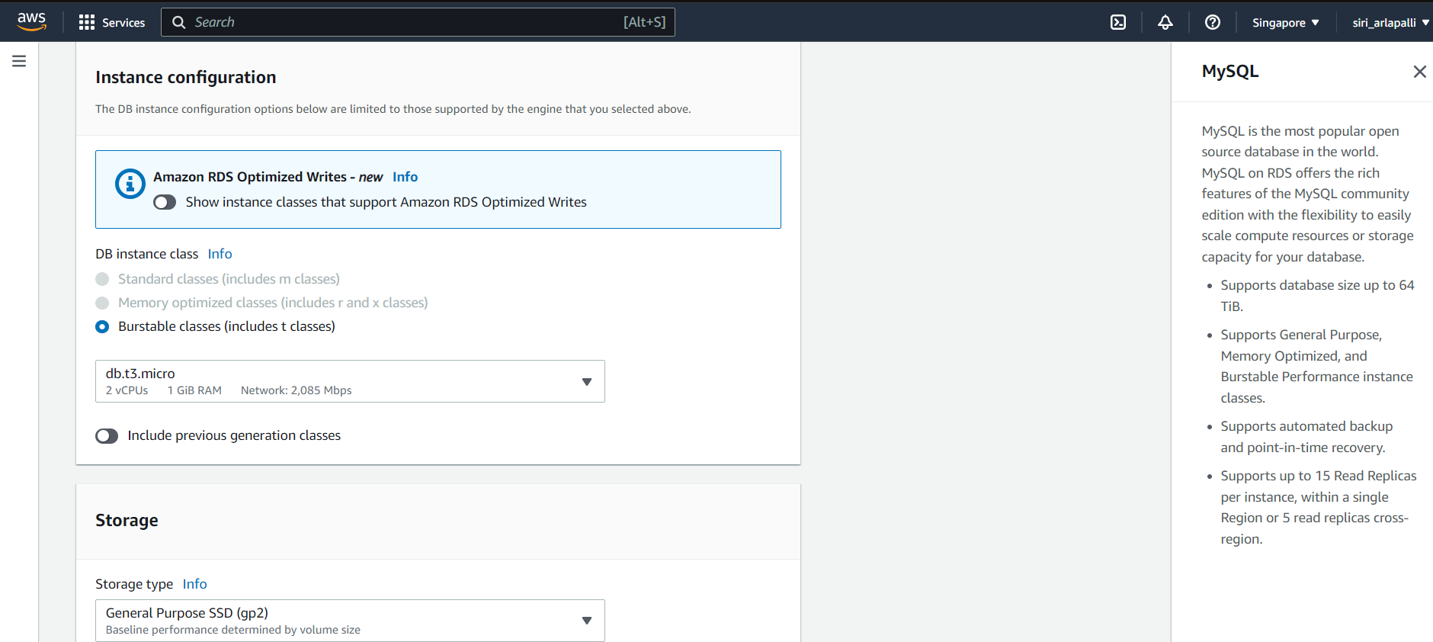

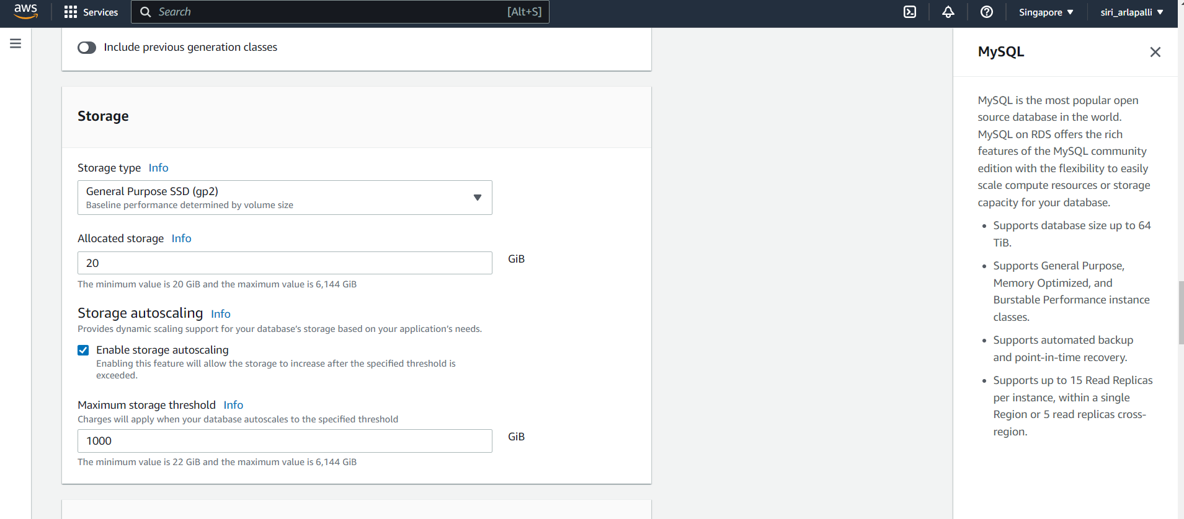

* Choose the VPC and create the DB subnet group, this should allow only mysql from any source.

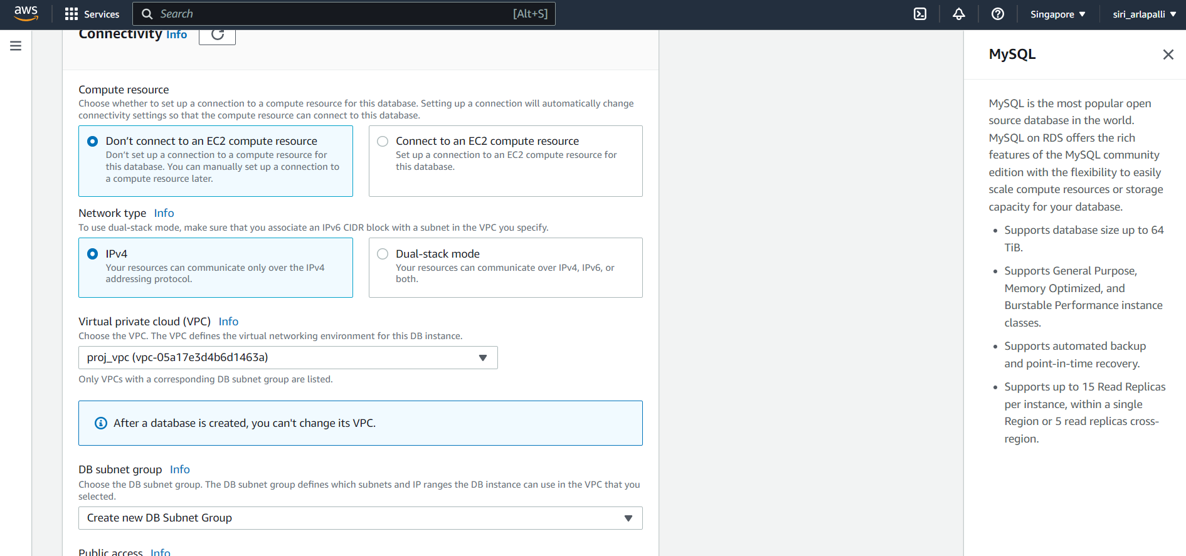

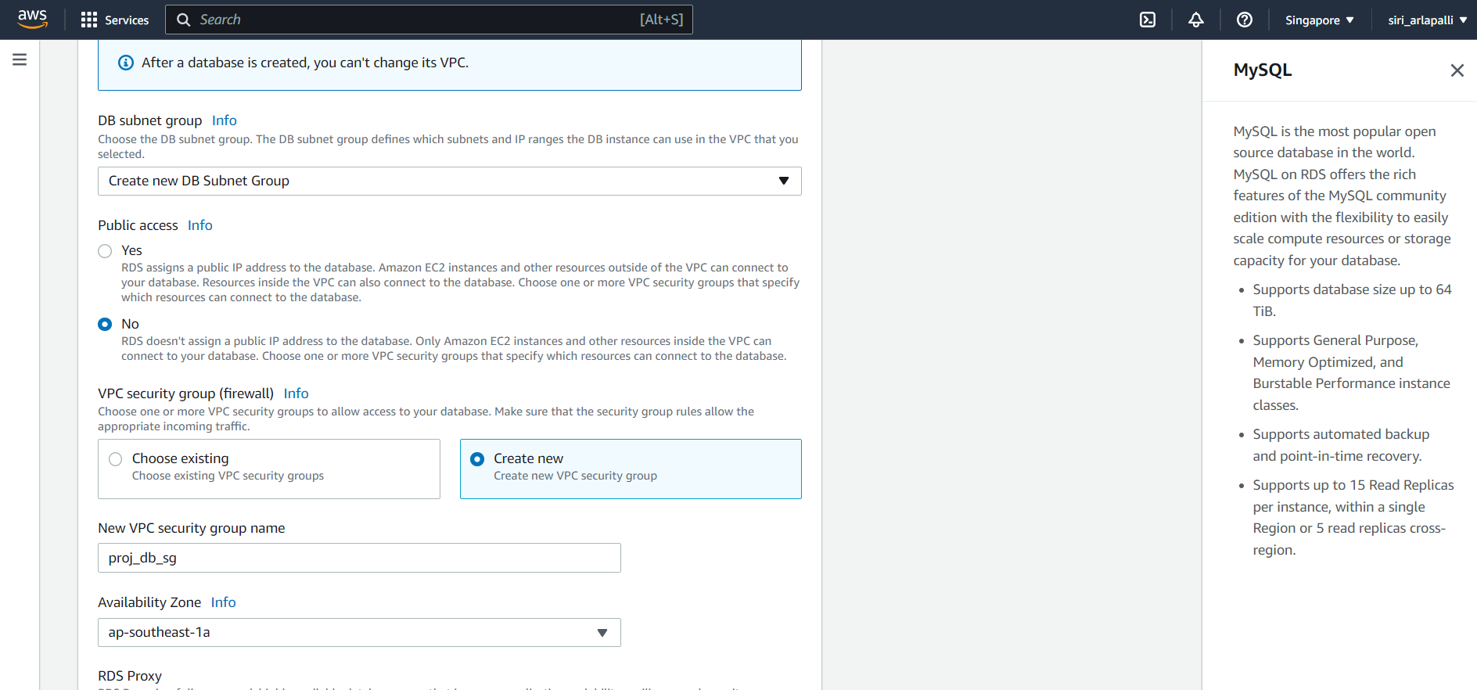

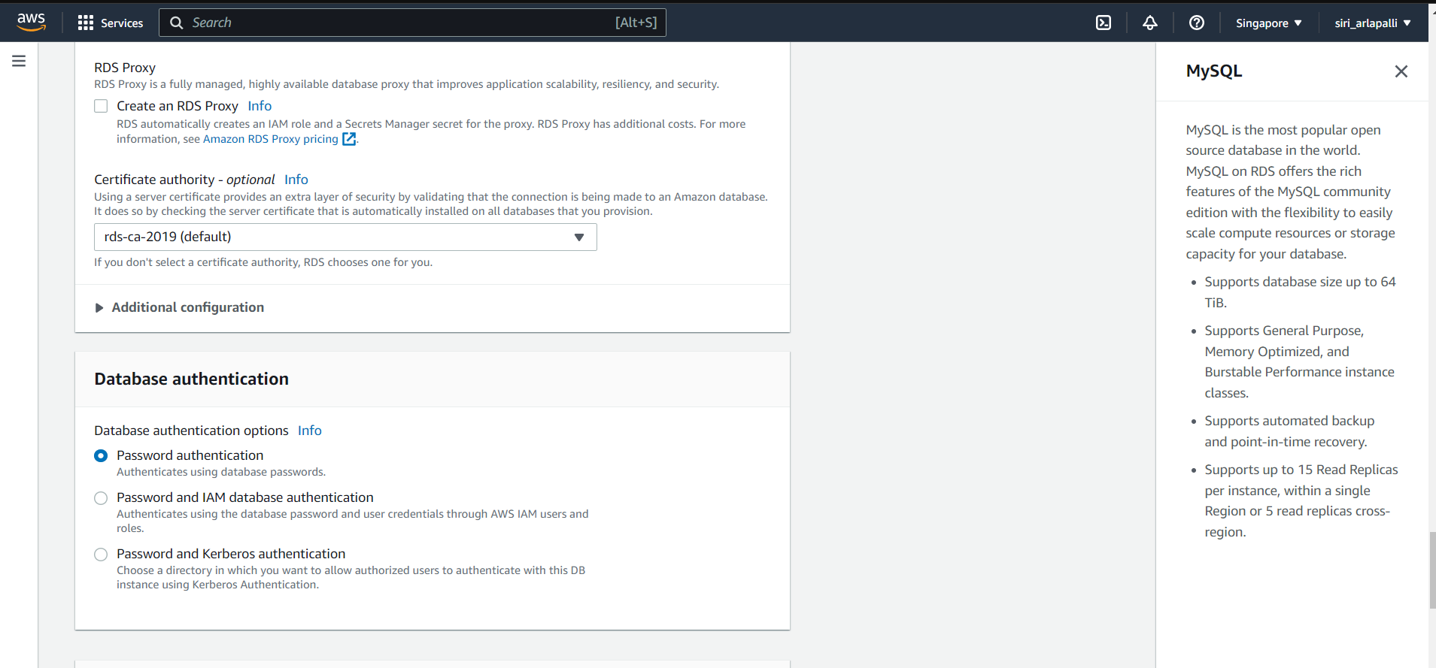

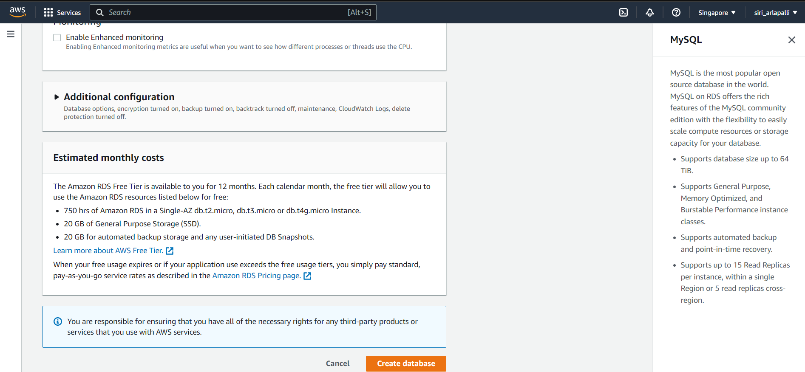

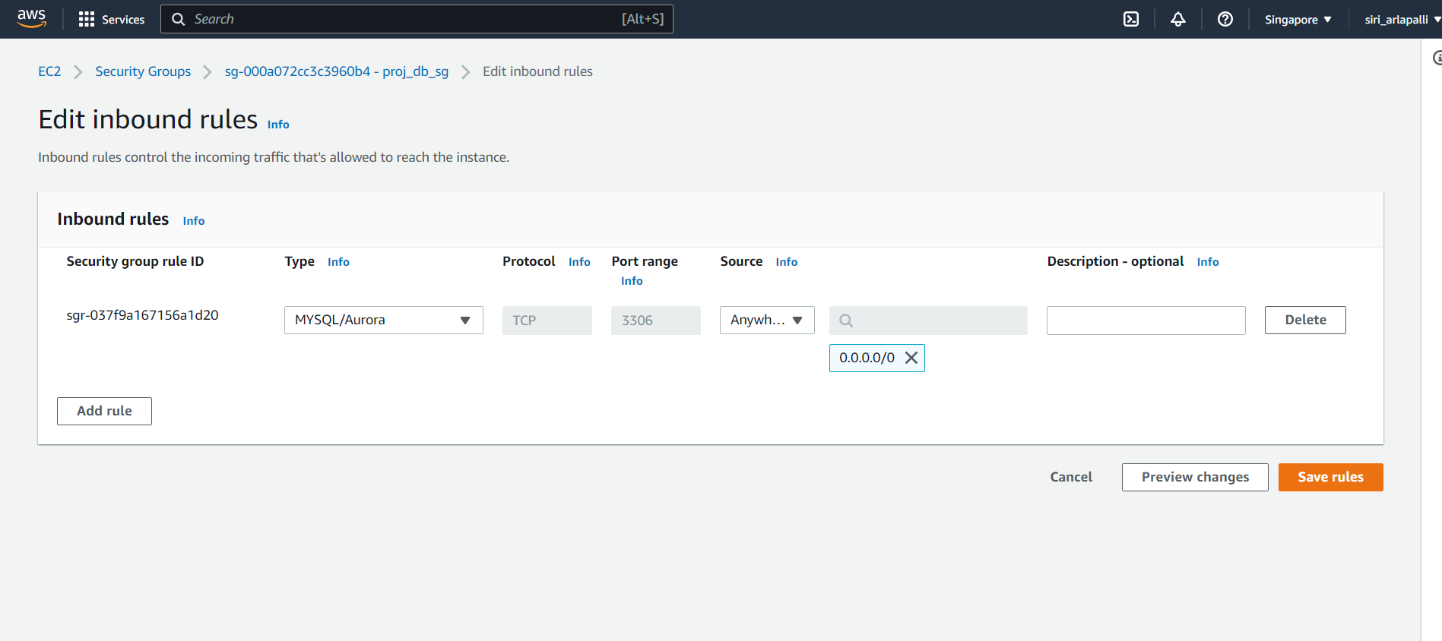



* Connect to the public instance from EC2 console.
* In the public instance, install the required software such as mysql and php.
* The commands used are

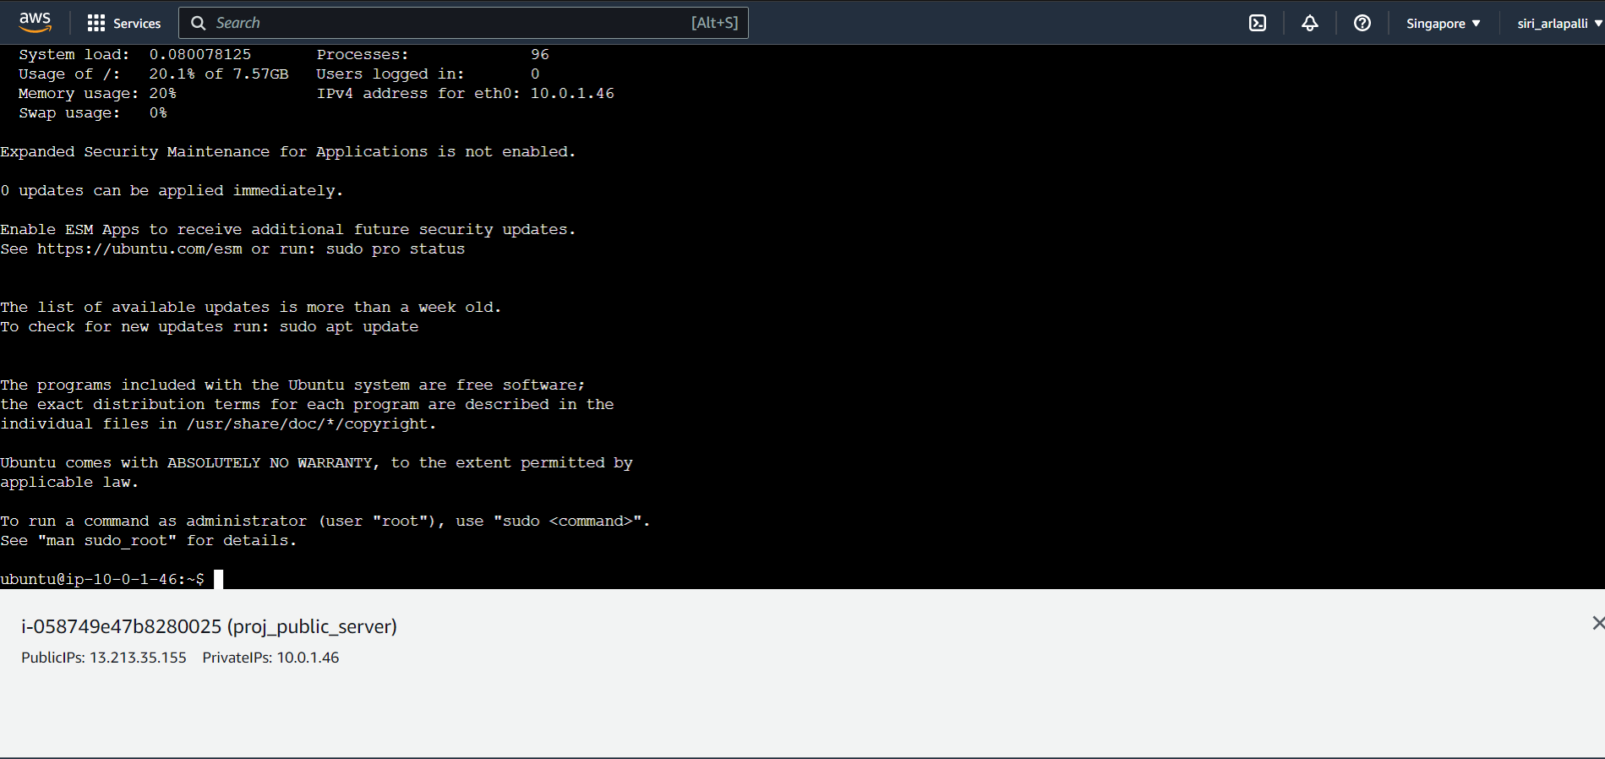

**$sudo apt update**

* "sudo apt update" is a command used in Linux-based operating systems to update the package lists from repositories.
* It requires administrative privileges to execute, hence the "sudo" (superuser do) prefix.
* Running this command ensures that the system has the latest information about available software updates and helps to keep the system secure and up to date.

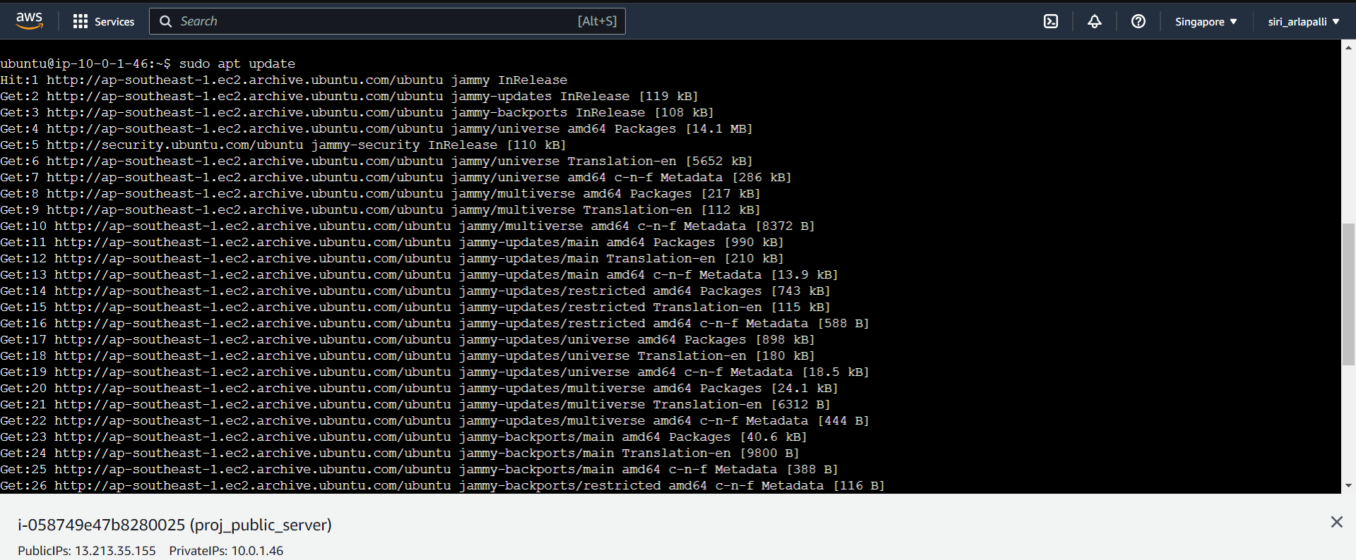

**$sudo apt install php libapache2-mod-php php-mysql**

* The command "sudo apt install php libapache2-mod-php php-mysql" is used in Linux-based operating systems to install PHP programming language and its modules required for running PHP applications on Apache web server.

Here is what each package does:

**php**: Installs PHP programming language.

**libapache2-mod-php:** Installs the Apache module for PHP, which allows Apache to process PHP scripts.

**php-mysql:** Installs MySQL module for PHP, which allows PHP to interact with MySQL databases.

This command requires administrative privileges to execute, hence the "sudo" (superuser do) prefix. Running this command will download and install the required packages and their dependencies from the package repository. Once installed, you can start using PHP to develop and run dynamic web applications on Apache web server.

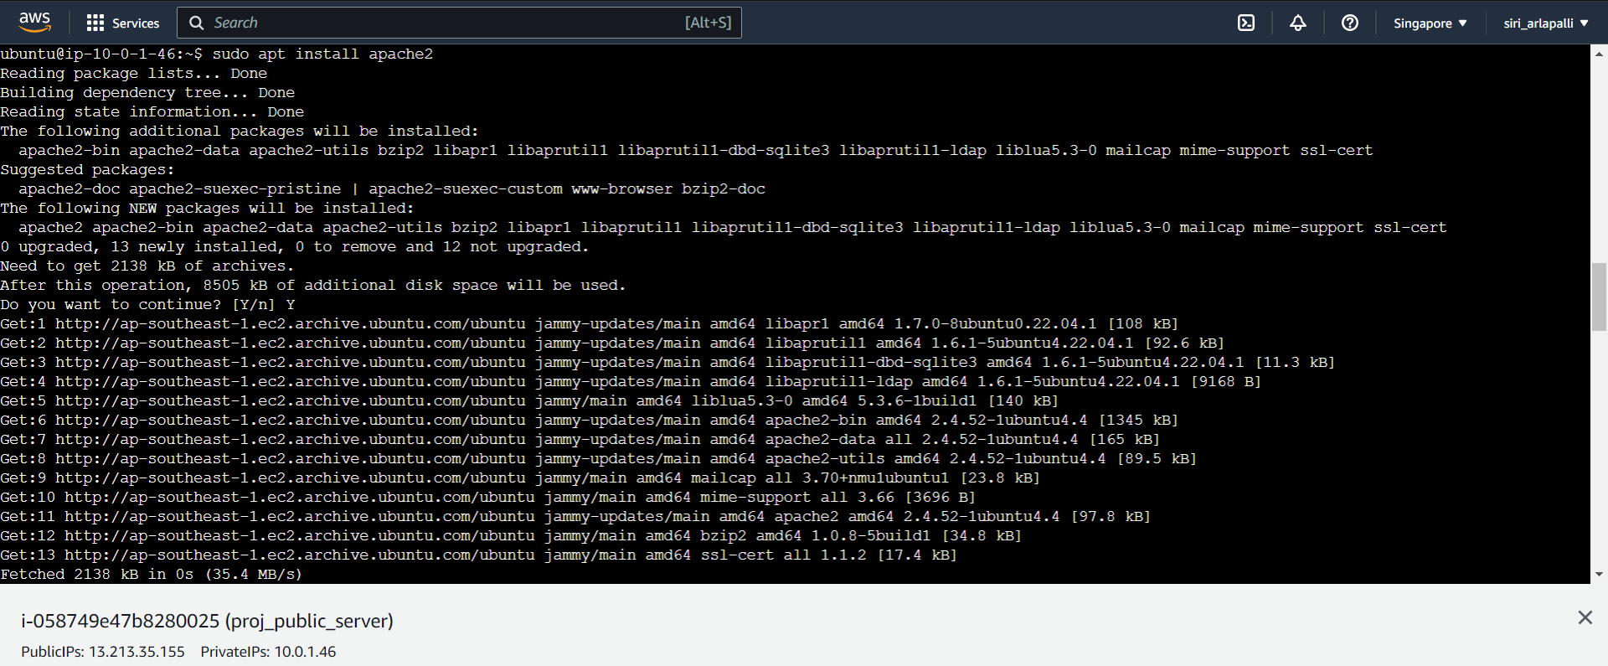

**$sudo apt install mysql-client-core-8.0**

The "sudo apt install mysql-client-core-8.0" command is used in Linux-based operating systems to install the MySQL client core package, which provides the necessary components for connecting to a MySQL server and executing SQL queries.

The package version "mysql-client-core-8.0" corresponds to the MySQL version 8.0. When you run this command with administrative privileges (i.e., using the "sudo" command), the package manager will download and install the MySQL client core package and its dependencies from the package repository.

After installation, you can use the "mysql" command in the terminal or command prompt to connect to a MySQL server and execute SQL queries. However, note that this command does not install the MySQL server itself, only the client package required for connecting to it.

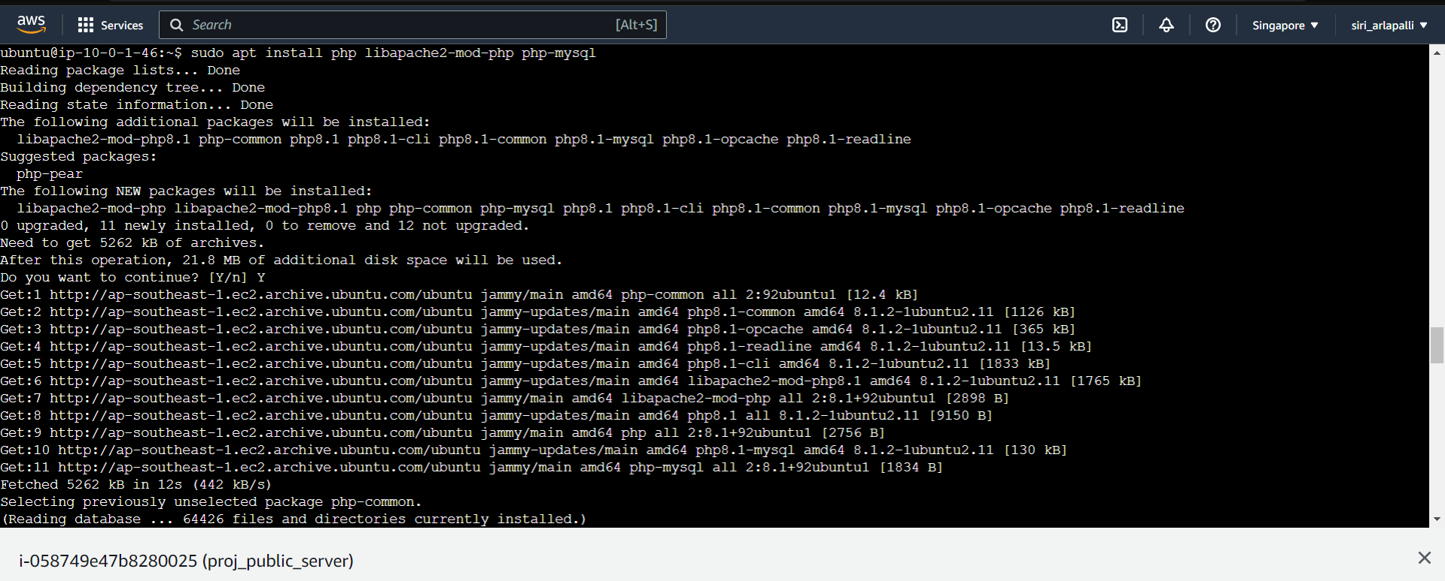

**$mysql –version**

The "mysql --version" command is used to check the version of MySQL database software installed on a system. When executed in a terminal or command prompt, it will display the version number of MySQL installed on the system.

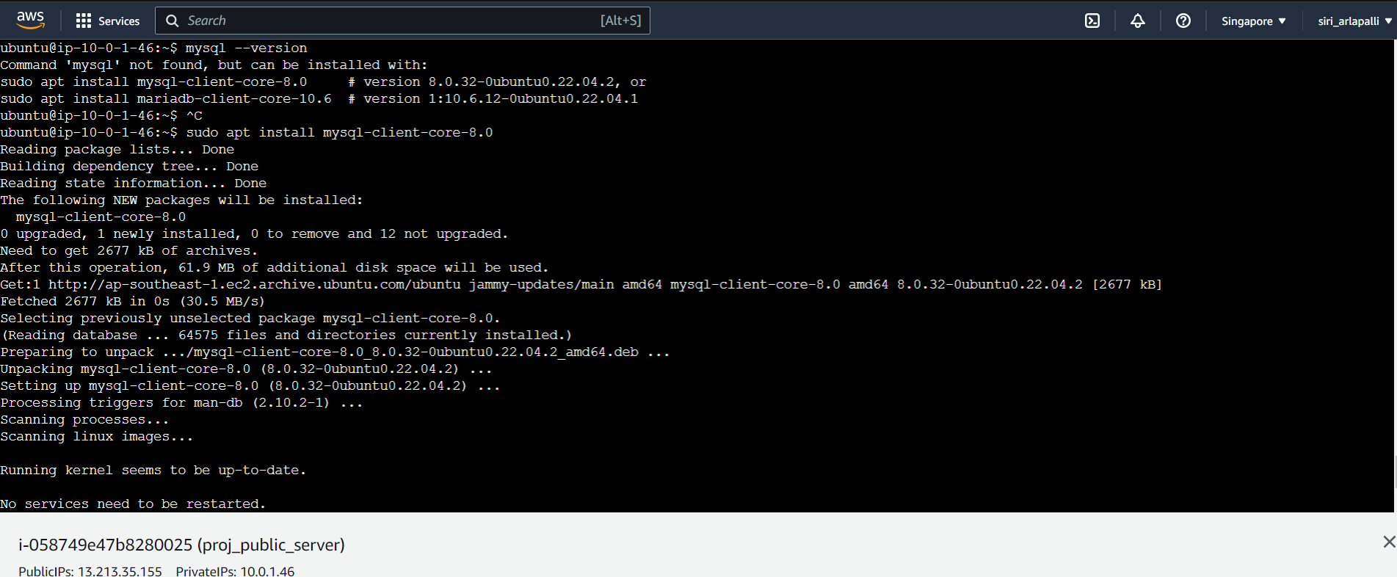

**$sudo rm index.html**

By default in var/www/html you have the index.html,for the front end web page creation remove the index.html using the rm command and create the file index.html using the command **sudo nano index.html**

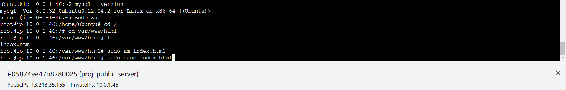

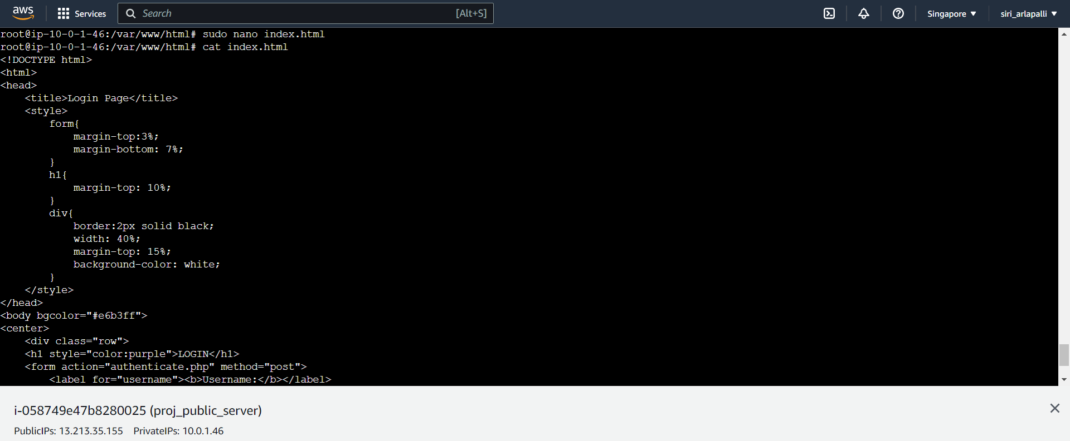

Create another file authenticate.php for the back end .



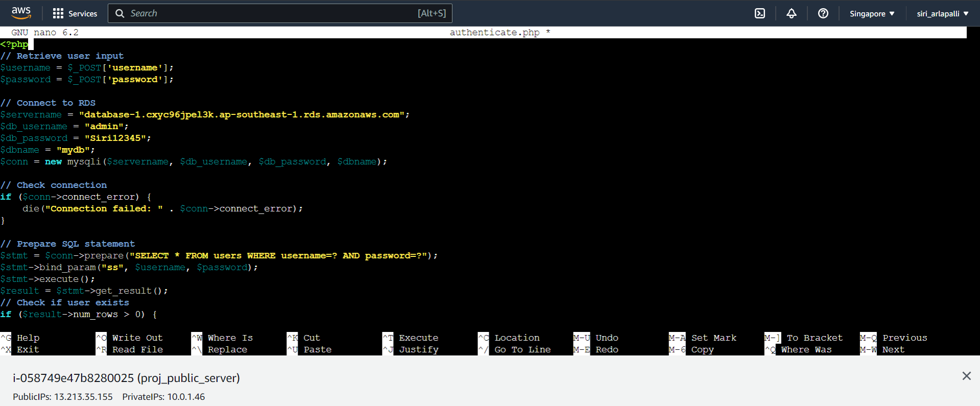



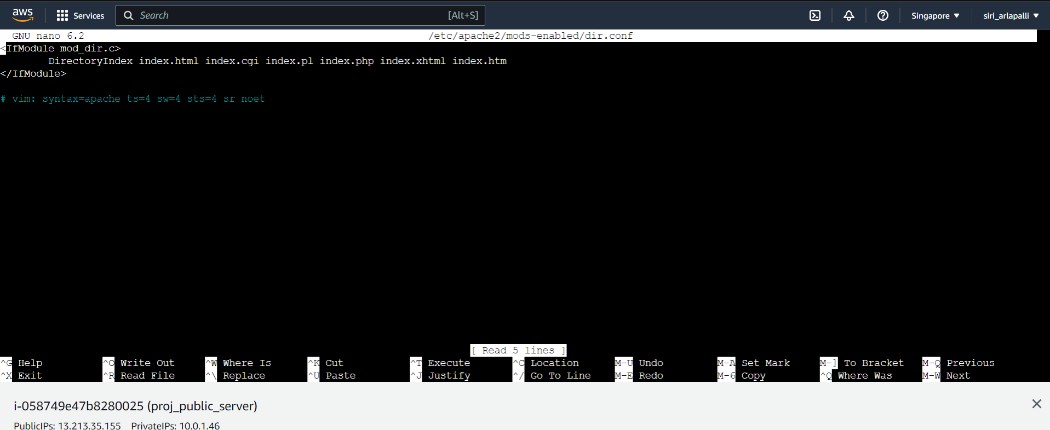

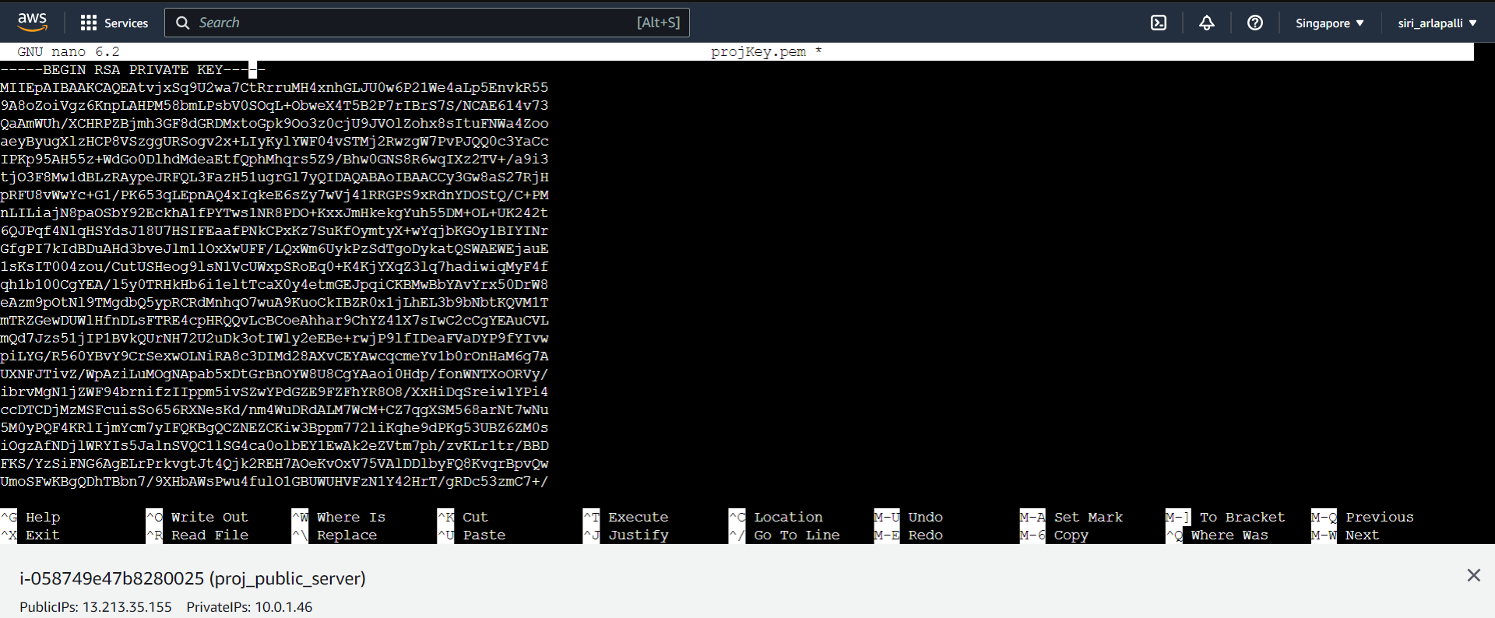

*from the public instance, connect to the private EC2 instance.

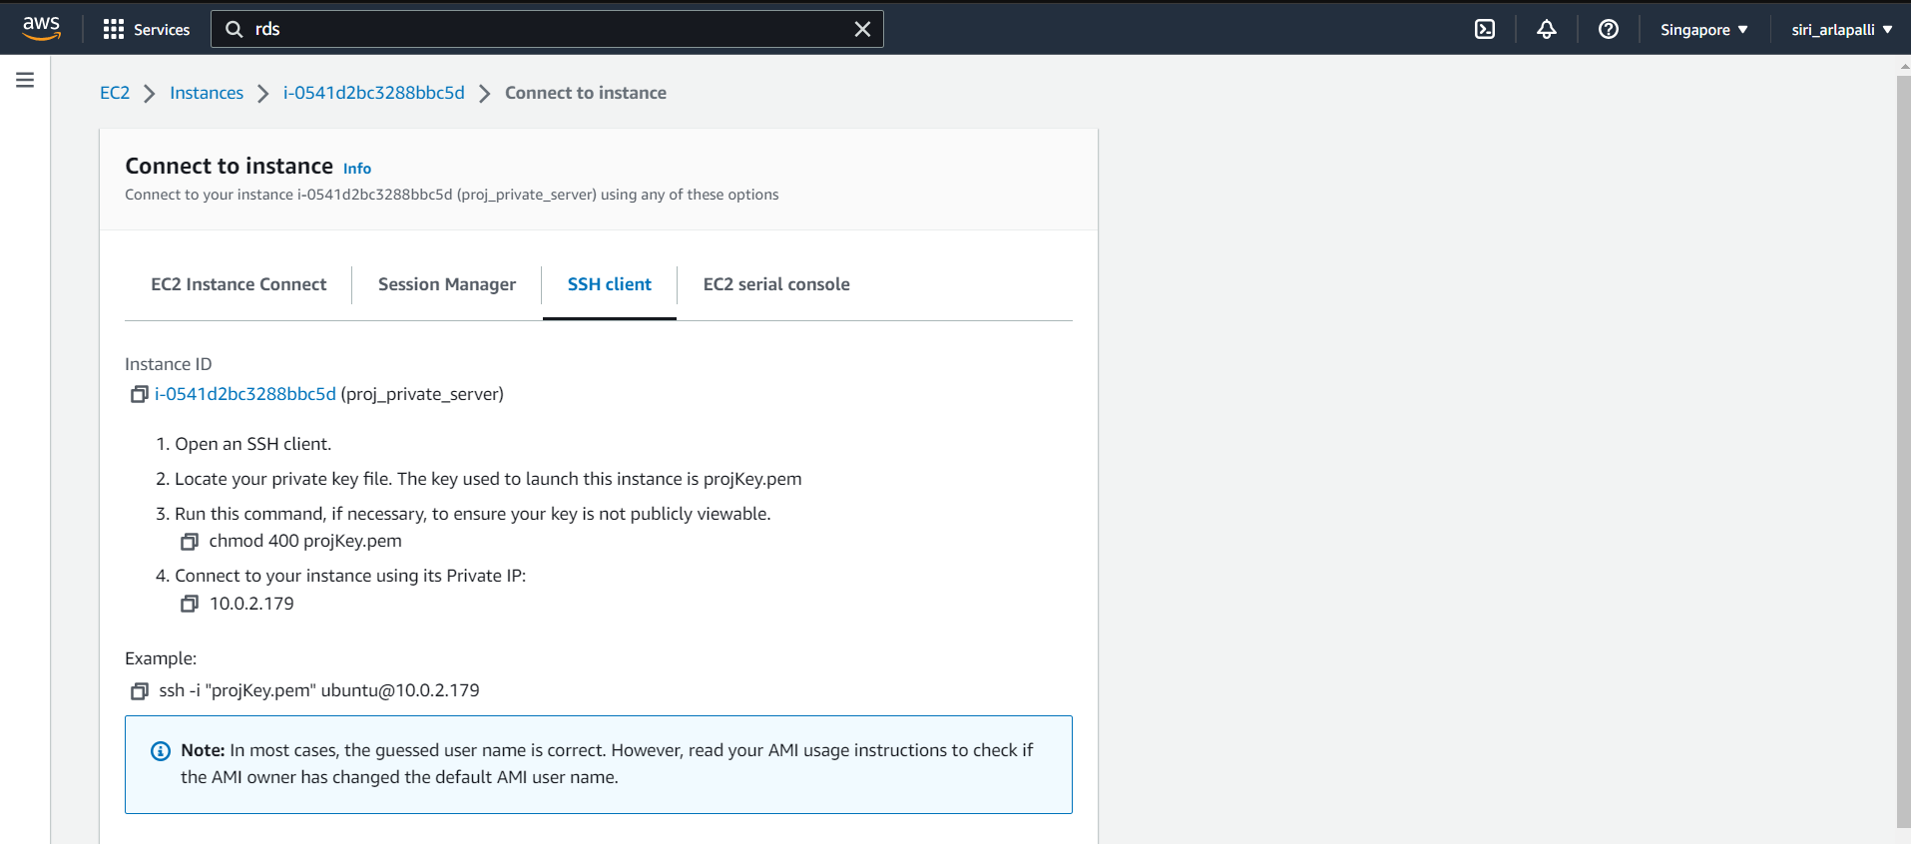

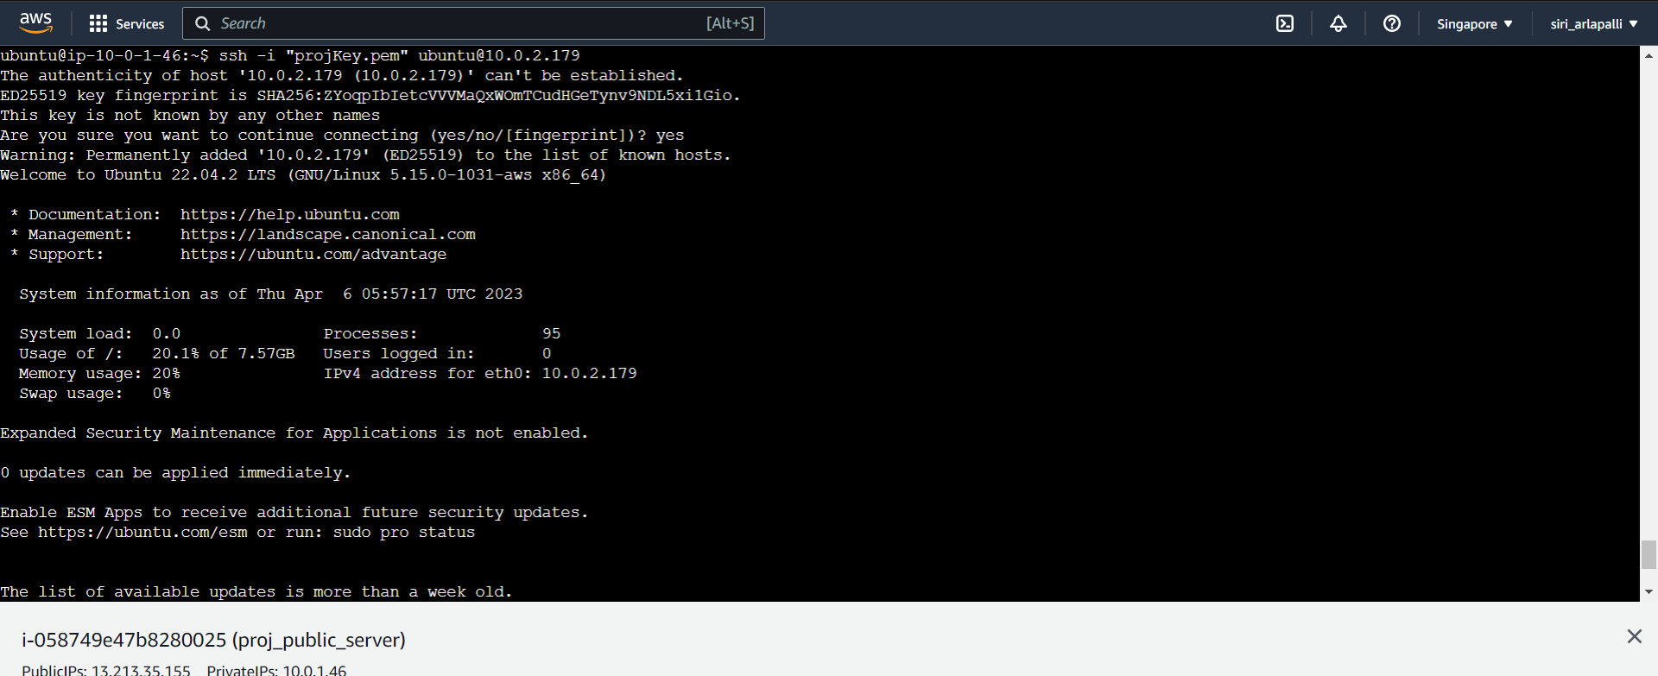

*To install the mysql server use the command

**$sudo apt-get install mysql-server**

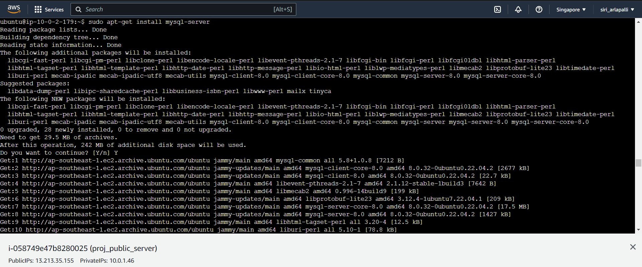

*check the version of mysql using the command

**$mysql --version**

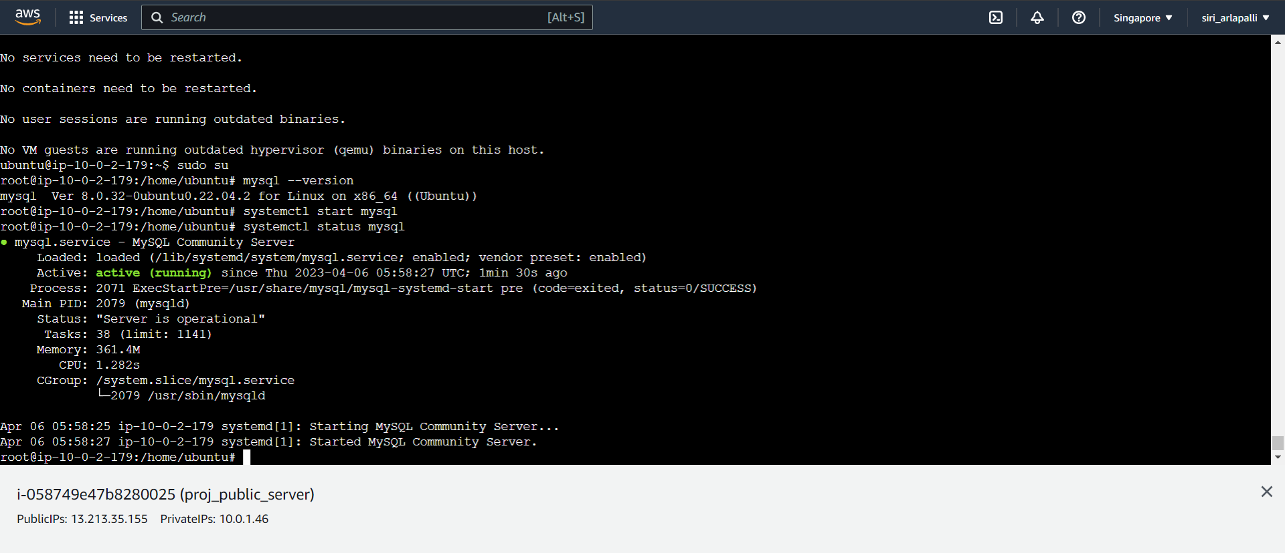



$**mysql -h database-end-point -P 3306 -u admin -p**

This command is used to connect to a MySQL database server using the command line interface.

Here is the breakdown of the different parts of the command:

mysql: This is the command to start the MySQL client program.

-h: This option specifies the hostname or IP address of the MySQL server.

database-endpoint: This is the hostname or IP address of the MySQL server.

-P: This option specifies the port number to use for the connection. The default port for MySQL is 3306, which is why it is specified here.

3306: This is the port number for the MySQL server.

-u: This option specifies the username to use for the connection.

admin: This is the username for the MySQL server.

-p: This option prompts for a password to be entered. When you run the command, you will be prompted to enter the password for the specified user.

After running this command, if the username and password are correct, you will be logged in to the MySQL server and can start executing SQL commands.

**mysql>create database mydb;**

This command is used to create a new MySQL database with the name "mydb". Here is a breakdown of the command:

create database: This specifies that we want to create a new database.

mydb: This is the name of the database that we want to create.

After running this command, the new database "mydb" will be created in the MySQL server. Note that the user running the command must have sufficient privileges to create databases in the server.

**mysql>use mydb;**

This command is used to select a specific database in MySQL server and start using it for executing SQL commands. Here is a breakdown of the command:

use: This specifies that we want to select a specific database to use.

mydb: This is the name of the database that we want to select.

After running this command, any SQL commands that we execute will be executed in the context of the "mydb" database. If the database doesn't exist, an error will be returned.

**mysql>CREATE TABLE users (**

**username VARCHAR(50) NOT NULL,**

**password VARCHAR(255) NOT NULL**

**);**

This command is used to create a new table named "users" in the current database, with two columns: "username" and "password". Here is a breakdown of the command:

CREATE TABLE: This specifies that we want to create a new table.

users: This is the name of the table that we want to create.

username: This is the name of the first column in the table, which will hold usernames. It has a data type of VARCHAR(50), which means it can hold up to 50 characters of variable length.

NOT NULL: This specifies that the "username" column cannot be empty or NULL.

password: This is the name of the second column in the table, which will hold passwords. It has a data type of VARCHAR(255), which means it can hold up to 255 characters of variable length.

NOT NULL: This specifies that the "password" column cannot be empty or NULL.

After running this command, the new table "users" will be created in the current database, with the two specified columns. Note that there are other data types and column constraints that can be used when creating tables in MySQL, depending on the specific needs of your application.

**mysql>INSERT INTO users (username, password) VALUES ('john', 'password123');**

This command is used to insert a new row of data into the "users" table with the specified values for the "username" and "password" columns. Here is a breakdown of the command:

INSERT INTO: This specifies that we want to insert data into a table.

users: This is the name of the table that we want to insert data into.

(username, password): These are the names of the columns that we want to insert data into.

VALUES: This specifies that we want to specify the values to insert.

('john', 'password123'): These are the actual values that we want to insert into the "username" and "password" columns, respectively.

After running this command, a new row will be added to the "users" table with the specified values for the "username" and "password" columns. Note that if a column has a NOT NULL constraint and no value is specified, the insert statement will fail with an error.

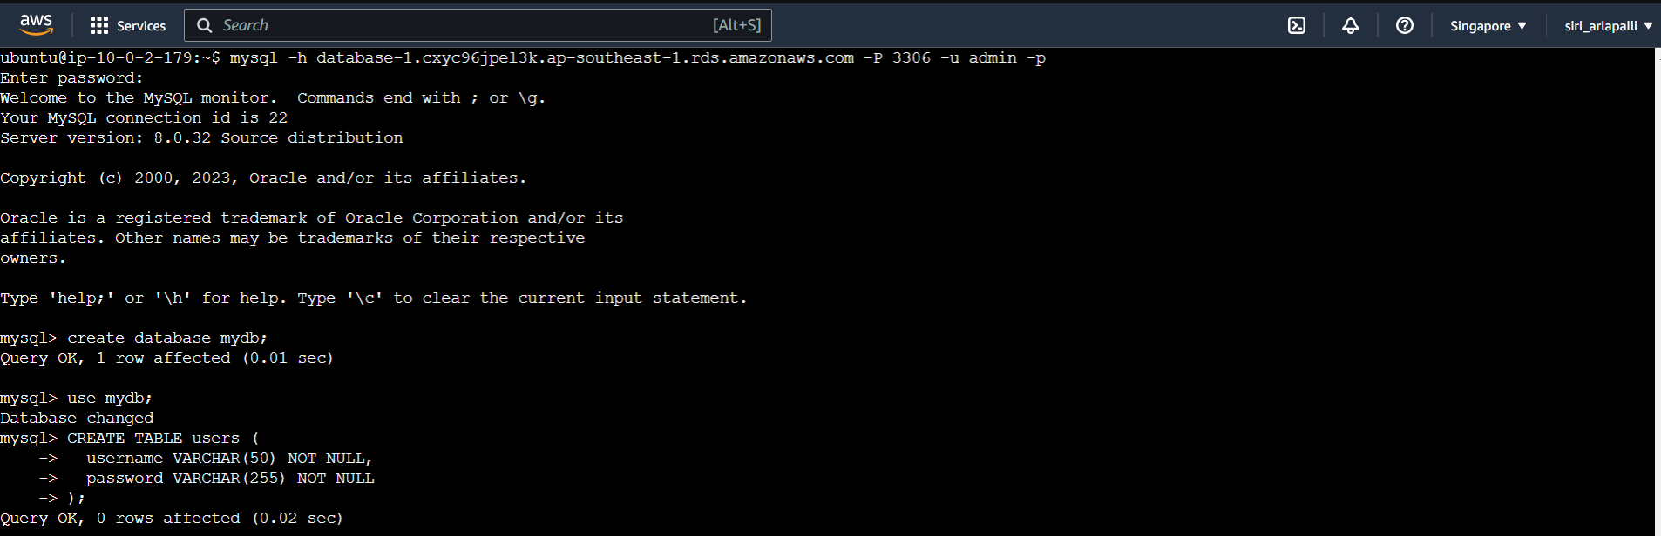

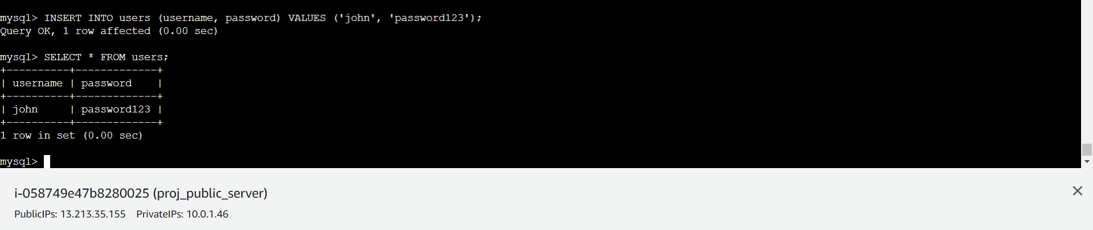

**mysql>SELECT * from users;**

"SELECT * FROM users" would retrieve all the data from the "users" table in a relational database. The asterisk (*) is a wildcard character that represents all columns in the table. This query would return all the rows and columns in the "users" table, showing information about each user stored in the table.

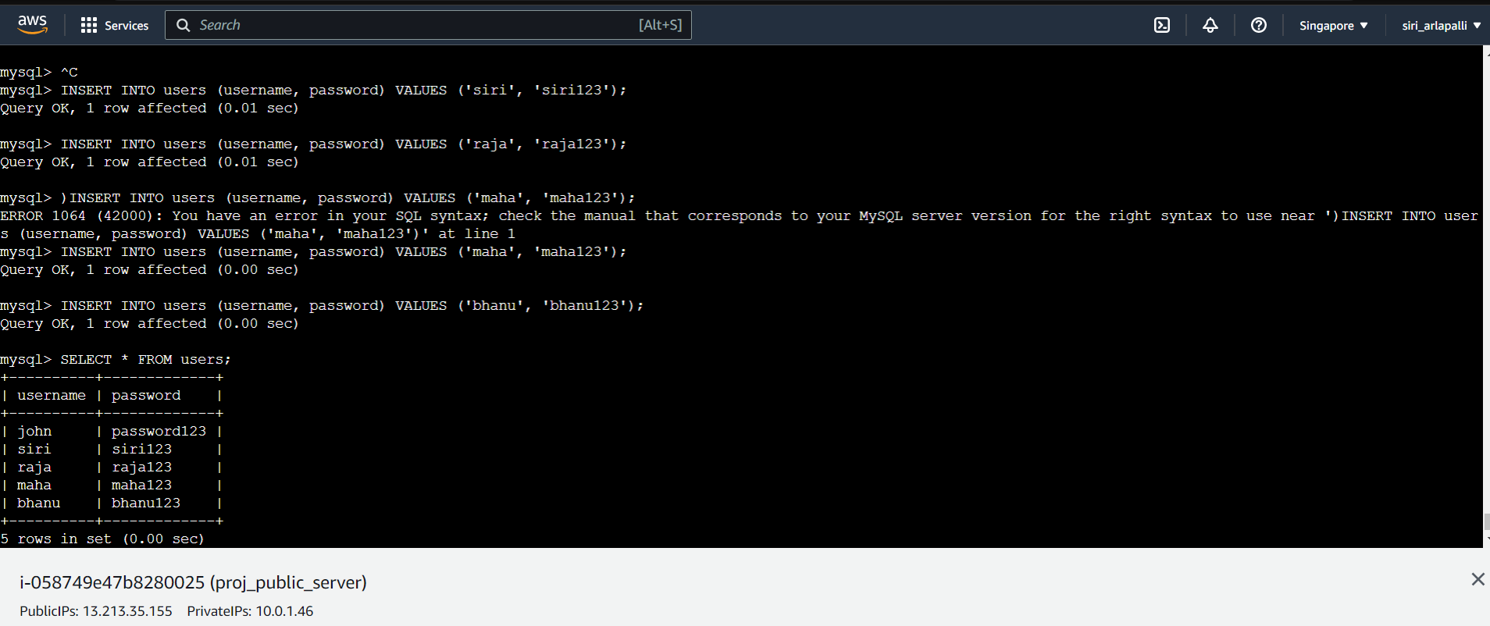

**Reference Links:**

[**https://awstip.com/lets-create-3-tier-architecture-with-aws-6c836bddc023**](https://awstip.com/lets-create-3-tier-architecture-with-aws-6c836bddc023)

[**https://medium.com/the-andela-way/designing-a-three-tier-architecture-in-aws-e5c24671f124**](https://medium.com/the-andela-way/designing-a-three-tier-architecture-in-aws-e5c24671f124)

[**https://thornelabs.net/posts/deploy-a-three-tier-web-application-to-kubernetes/**](https://thornelabs.net/posts/deploy-a-three-tier-web-application-to-kubernetes/)

[**https://www.c-sharpcorner.com/article/how-to-create-aws/**](https://www.c-sharpcorner.com/article/how-to-create-aws/)

[**https://chat.openai.com/chat**](https://chat.openai.com/chat)

**OUTCOMES:**

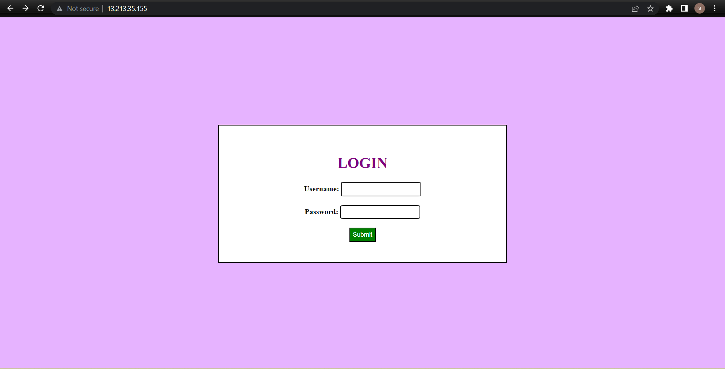

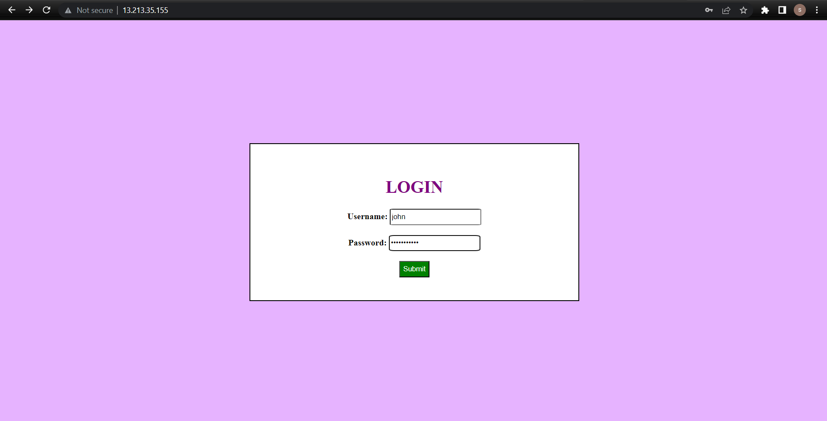

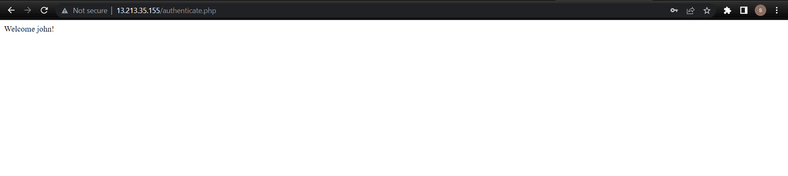

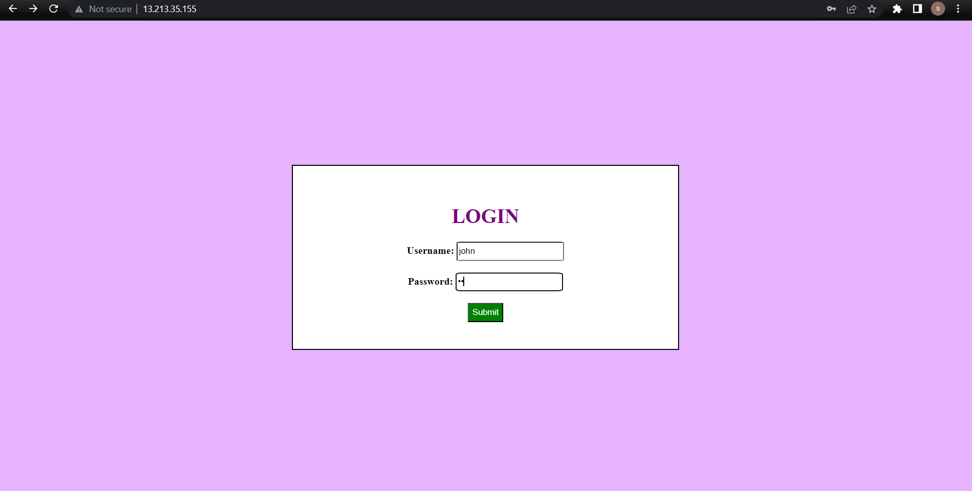

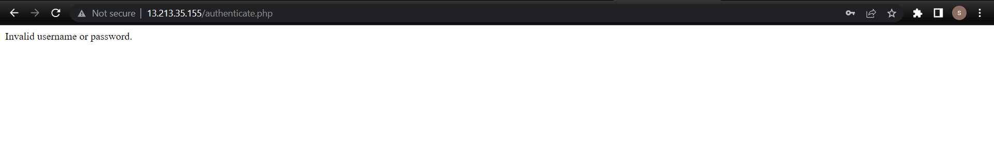

**CONCLUSION**

* We have successfully deployed a 3 tier web application in AWS cloud.
* Deploying a three-tier web application in the cloud offers numerous benefits and is a recommended approach for organizations looking to provide a scalable, available, and cost-effective solution to their users.